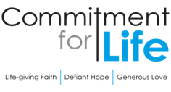
Moving
Stories
Committed to supporting our global partners BANGLADESH

Harvest service
In July 2023 our Programme Officer Kevin Snyman travelled to Zimbabwe. He concentrated his
visit in the north-east and south-east of the country, visiting our Christian Aid partners to and hearing the good news stories from locals who have benefitted so enormously from our partnership. “I’m grateful to the Christian Aid Country Team that facilitated our visit,” says Kevin.
“The hospitality was always so generously offered, and I saw many examples of how effective our work in the region has been.”

This year’s harvest service focuses on Zimbabwe. You can find and download the PDF, Word, and PowerPoints for your harvest service on our Commitment for Life website under “order or download resources” and scroll down to ‘services of worship’.

Prayer
Thank you, Jesus, for your presence in our lives. We bless and praise you for the many gifts you pour so generously into our lives. May we be transformed by the infilling of your Holy Spirit to perfectly love you through our care and support for our neighbour in need. And, in so doing, may we increasingly come to resemble you. Amen.

Fast Fashion –
a detrimental effect on the Environment
Photo: by Tarekmoshin, Pixabay
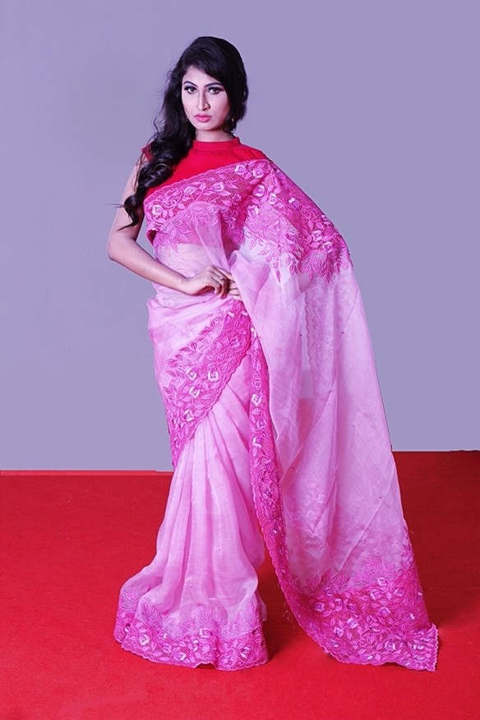
Bangladesh is the second largest garment exporter
in the world, providing millions of garments to the UK market.
Large numbers of high street fashion brands in
the UK are buying from factories in Bangladesh, according to one study ‘Impact of Global Clothing Retailers’ Unfair Practices on Bangladeshi Suppliers During COVID-19’.
Many factories are struggling to pay the Bangladeshi daily minimum wage of £2.30 due to rising costs and the burden of shareholder dividends.
The rise of fast fashion has a profoundly detrimental effect on the environment. One cotton shirt requires roughly 700 gallons of water overall. The fashion industry produces 5% of the world's greenhouse
gas emissions, or 2.1 billion tons of CO2 annually.
This is more than shipping and aviation combined! Next time you shop for clothes, think:
• Where is the garment made? Are working
conditions safe? Do the workers get a
living wage?
• Will I wear this garment a minimum of 30 times?
• Could I rather use a charity shop?
• Will I take the ‘30-wear’ pledge’?

