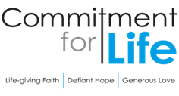
Moving
Stories
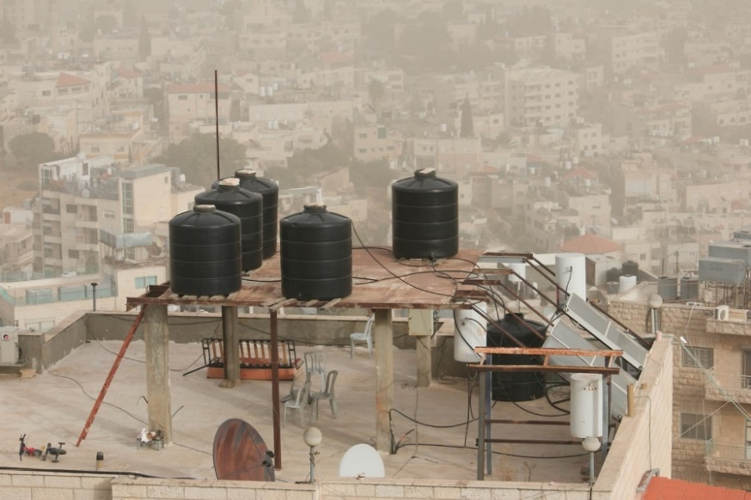
Committed to supporting Israel and the occupied Palestinian territory.
Photo: Kevin Snyman
Where will Greta get to visit this summer?
Greta’s flying disc with object lesson is made from recycled plastic and is aimed at helping children and young people learn about Commitment for Life. Cathy, the receptionist at Church House recently took one over 5000 miles to Seychelles, to play with family on the beach in Mahe!

Like all nations, the Seychelles is feeling the effects of the climate crisis, through experiencing hotter than normal weather, and higher tides. This affects wellbeing, vegetation, travel as everything is disrupted. One way in which the population is managing the change in climate is by reclaiming its heritage through making things such as fans and baskets from leaves.
Are you going away this
year, why not take with you Greta’s flying disc. They are obtainable from commitmentforlife@urc.org.ukWhen home send us a picture of where you have taken it.

Prayer
Dear God, thank you for the wonders of your creation.
As we visit places this summer
to see, enjoy its beauty, and recreation, may we do so in an environmentally friendly way, leaving only our footprints
behind us. Amen

Water Shortages in the West Bank
Our Christian Aid partner in IOPT, B’Tselem, has issued a report that gives insight into the severe
water crisis among Palestinians in the West Bank.
The shortage is not the result of natural disasters, but as a direct result of Israeli government policies that would appear to prejudice Palestinians.

Israelis, including those living in illegal settlements, use an average of 247 litres of water a day per person. This is three times the quantity used by Palestinians in the West Bank at 82.4 litres. For Palestinian communities that are not hooked up to the water grid, the average daily water consumption is a mere 26 litres per person, not unlike many disaster zones. 92% of Palestinians in the West Bank store water in tanks on their rooftops to counter the chronic water shortage.

Because of your generous support for Christian Aid in occupied Palestine and Israel through Commitment for Life, you are supporting advocates and policy experts who are working towards a just and peaceful resolution of this deeply unfair situation.

