Moving
Stories
Committed to supporting Bangladesh
Where will Greta get to visit this summer?
Greta’s flying disc with object lesson is made from recycled plastic and is aimed at helping children and young people learn about Commitment for Life. Cathy, the receptionist at Church House recently took one over 5000 miles to Seychelles, to play with family on the beach in Mahe!

Like all nations, the Seychelles is feeling the effects of the climate crisis, through experiencing hotter than normal weather, and higher tides. This affects wellbeing, vegetation, travel as everything is disrupted. One way in which the population is managing the change in climate is by reclaiming its heritage through making things such as fans and baskets from leaves.
Are you going away this
year, why not take with you Greta’s flying disc. They are obtainable from commitmentforlife@urc.org.ukWhen home send us a picture of where you have taken it.

Prayer
Dear God, thank you for the wonders of your creation.
As we visit places this summer
to see, enjoy its beauty, and recreation, may we do so in an environmentally friendly way, leaving only our footprints
behind us. Amen

Facing floods:
What the world can learn from Bangladesh's climate solutions
Bangladesh is one of the worst affected countries due to increased flooding. It now leads the way in adaptation and resilience.
Majida Begum lives a two-hour boat ride from the nearest road – and farther still from any flood shelter. She doesn't read or write and doesn't have a mobile phone. Seasonal floods are a part of life on the riverbank where Majida Begum lives in Sunamganj, northern Bangladesh. Each spring, when monsoon rains arrive, a web of narrow rivers swell into a shallow sea. The 2022 floods were the worst Begum had ever seen. All at once her thatch and bamboo home was swept away.
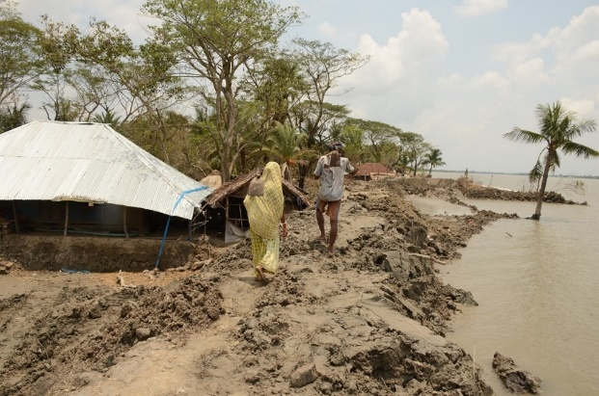
However, Begum knew precisely when to evacuate because of a human chain of communication that relies on high-tech forecasting and low-tech relationships. It all starts with Nazma Akter, 26, a housewife, who five times a day reads a gauge set into her local river. She sends the results to Dhaka’s Flood Forecasting and Warning Centre by text. In June 2022 Akter noticed that the river had risen by 2.5 meter over three days. Severe flash floods were likely. Begum does not have a phone, but. her neighbours' nephew heard the warning. Many in her village slept on their fishing boat for three days, and everyone survived!
Commitment for Life supports Christian Aid’s work in resilience and adaptation in Bangladesh. Thank you for all your support.
Photo: gmkhairul/Pixabay

