COMMITMENT FOR LIFE HARVEST SERVICE 2022
PRELUDE: Gloria in D Major Laudamus Te / or suitable

WORDS OF WELCOME / CALL TO WORSHIP

We bless you, God of Seed and Harvest,
and we bless one other, that the beauty of this world, and the love that created it, might be expressed though our lives and be a blessing to others, now and always. Amen.

Hymn 1: Great is They Faithfulness/Oh For a Thousand Tongues / or suitable

Opening Prayers

By your Word love was established, In the beauty of each created thing, love was established.

God of Peace, sow seeds of hope in barren lands.

That all might look to the mountain, the fertile field, and the lush green valley, and there with crops to grow, flocks to tend, vineyards to plant, and communities to nurture we find your love, peace, justice, and laughter:
God of Peace, sow seeds of hope in barren lands.

By your Word humanity is given the gift of true freedom to live life within the safety of your love. But Man chooses to corrupt your laws and economics and worship Empire instead: setting up ruler and slave, rich and poor, weak and strong, victor and vanquished, satisfied and starving.

God of Peace, sow seeds of hope in barren lands

Come, God of the harvest and water the garden with the tears of your weeping, that we may hear your cry and repent of evil, and come out of Systems of Empire into the kin-dom of Jesus, who taught us to pray:

Abba, God, Parent of All
Hallowed be your name
May your Kin-dom of love burst into this world as it is in heaven.
Give us today our daily bread
And forgive us our debt
Even as we dismantle all debts owed to us
Lead us away from the temptations of Empire
And deliver us from its evil systems
For yours are all the kingdoms of this world
Transformed by your justice and peace both now and forever.
Amen
Hymn 2: Suitable for your context

Hebrew Scriptures
Genesis 2:8 – 15 (ETR Version)
⁸ Then the Lord God planted a garden in the East,^{[a]} in a place named Eden. God put the human they made in that garden. ⁹ Then the Lord God caused all the beautiful trees that were good for food to grow in the garden. In the middle of the garden, they put the tree of life and the tree that gives knowledge about good and evil.
¹⁰ A river flowed from Eden and watered the garden. The river then separated and became four smaller rivers. ¹¹ The name of the first river was Pishon. This river flowed around the entire country of Havilah. ¹² (There is gold in that country, and that gold is pure. A kind of expensive perfume and onyx are also found there.) ¹³ The name of the second river was Gihon. This river flowed around the whole land of Cush. ¹⁴ The name of the third river was Tigris. This river flowed east of Assyria. The fourth river was the Euphrates.¹⁵ The Lord God put the human in the Garden of Eden to work the soil and take care of the garden.

Hosea 8:7
⁷ The Israelites did a foolish thing—it was like trying to plant the wind. But they will get only troubles—they will harvest a whirlwind. The grain in the fields will grow, but it will give no food. Even if it grew something, strangers would eat it.

CONTEMPLATION: Music Your Beautiful Green by Luis Berra or alternative

Gospel: Mark 4:26 – 29

²⁶ Then Jesus said, “God’s kingdom is like a man who plants seed in the ground. ²⁷ The seed begins to grow. It grows night and day. It doesn’t matter whether the man is sleeping or awake, the seed still grows. He doesn’t know how it happens. ²⁸ Without any help the ground produces grain. First the plant grows, then the head, and then all the grain in the head. ²⁹ When the grain is ready, the man cuts it. This is the harvest time.”
SERMON: Who makes the wind to blow?

I’m grateful to Christina for reading our scripture texts today. Christina is Studying medicine at the International University of Kyiv and hopes to become a dentist one day, but is not sure when that might be given the horrific war in Ukraine. Christina and her mum Olga are here in the UK as refugees, staying with me and Nadene, and while they have become family now and we don’t want them to leave, we also want them reunited with their loved ones back home.

Ukraine is an interesting country to think about during this our harvest service. Agriculture is huge in that country. It is the breadbasket of the world and supplies the EU with over 80% of its sunflower oil, 46 % of its rapeseed, and 26% of its honey.

The current war has sent shockwaves through the food price markets around the world, and many people in Africa are facing the possibility of starvation. Christian Aid has had to launch an East Africa hunger Appeal, warning that the war in Ukraine is causing food prices to rocket, forcing people in East Africa to take desperate measures to deed their families.

At Commitment for Life we concentrate our efforts on Zimbabwe rather than Kenya or Tanzania, but we are deeply concerned about the impact across the region made worse by this completely avoidable conflict in Ukraine.

Many people will be asking where God is in all of this suffering, and in today’s Hebrew Scriptures Christina reminded us about the Garden God created for humanity, a place of immense beauty and abundance – more food produced in this lovely place that we would ever need. And in addition, God gave people the knowledge of Good and Evil. If we follow God’s ways of love, nurture, and sharing, we’ll be fine. But we also know that by and large humanity has consistently rejected God’s ways in favour of what the Council for World Mission calls systems of empire. Give us a King! Demanded the people of God. We want to be like the other nations. But that king will take all your land, all your sons for his wars, all your daughters for his slaves, and your mothers to work his fields. You will no longer be free and will constantly be at war. Give us a king! They shouted even louder.

And by the time the prophet Hosea was writing, he’d already identified the damage to the earth caused by empire using a disturbing image: it was like trying to plant a whirlwind in a devastated landscape – and any food that the earth did produce was quickly snapped up by the wealthy.

The gospel is of course a calling for us to repent of our complicity with systems of empire: give back unto Caesar what belongs to Caesar, give up your blood-stained wealth earned on the backs of the poor in their sweatshop hells, and then come, pick up your cross to follow me.

I’m not sure how much longer we have to respond to this gospel call. The scientists tell us that we are entering an unprecedently dangerous period in the history of humanity. Our addiction to fossil fuels can no longer be sustained by the planet. Our dependence on industrialised farming is denuding the soils of their ability to sustain life. We have been planting whirlwinds for far too long.

But I have a confession to make: I am optimistic about the future. I don’t place my trust in technological solutions. I don’t place my trust in human systems. I’m not even too bothered about whether I’m around in 20 years’ time I somehow doubt it. My trust is in Christ the author and maker of all things. I remember a line from a worship song from my youth by a band called Dallas Holm and Praise, and the song went like this:

Who makes the wind to blow? Who brings the winter snow?
Who makes the grass to grow? Who saves the human soul?
Jesus, Jesus, he makes all to be: Jesus, Jesus, he means all to me

What I do know – and the science is clear on this – is that the world we see today, everything we have become accustomed to – it will be utterly different in 20 years’ time – either because the planet is so broken that we cannot survive it, or the planet has been given a chance to heal, because we have stopped the suicidal insanity of business-as-usual.

We need help of course. We can’t do this on our own. So, I invite you to pray, to repent, to have hope, and to have faith, and to rebel against everything that brings death and not life. Refuse to pick up a weapon to fight the wars of old, feuding, White men’, rebel against that fossil fuel company that’s refuses to shut down its operations. Don’t support the banking system with its debt-based economics that profits off the backs of the poor, say not to industrial farming methods. Grow your own food, harvest God’s abundant grace and give it away to those who ask, hold nothing back. None of us gets out of here alive anyway, so we might as well go all out to be Christ’s presence in this critical moment in human history.

Finally, let’s give thanks to God for organisations like Commitment for Life, Christian Aid, and Global Justice Now who really do try to make a difference. Pray that they deepen their commitment to justice and have the courage to make the right choices, the choices Jesus asks us to make: this Jesus, Jesus, who means all and is all. Amen.

HYMN: All Creatures of our God and King / or suitable

AFFIRMATION OF FAITH & INTERCESSIONS

Thank you for the gift of sunshine and rain in due season, of seed, soil and harvest, provision for our needs and others, if in love we share.
Thank you for the gift of living water that does not run dry and the nourishment of your Word which feeds our souls and others, if in love we share.
For love which endures, blessings which satisfy and the opportunity to share all that you have given, we bring to you our thanks.
We praise You, God, for all Your creatures,
especially for sister Sun, who is the day through whom You give us light. Sun is beautiful and radiant with great splendour,
of You Most High, she bears your likeness.
We praise You, God, especially for Sibling Moon and for our sibling stars, in the heavens you have made them bright, precious and fair.
We praise You, Lord, for Brother Water, so useful, humble, precious and pure.
We praise You, God, for Sister Earth, who sustains us with her fruits, coloured flowers, and herbs.
We praise You, Lord, for those who pardon, for love of You bear sickness and trial. Blessed are those who refuse to endure injustice for the sake of peace;
We thank You, God, for Sister Death, from whom no one living can escape. Blessed are those that She finds doing Your Will, for no second death can do them harm. Let us intercede for our loved ones, for the world, and for the planet:
Pause for private intercessions

GIVE THANKS TO GOD. AMEN.

CLOSING HYMN: Oh, for a thousand Tongues to Sing / or suitable

BENEDICTION
POSTLUDE

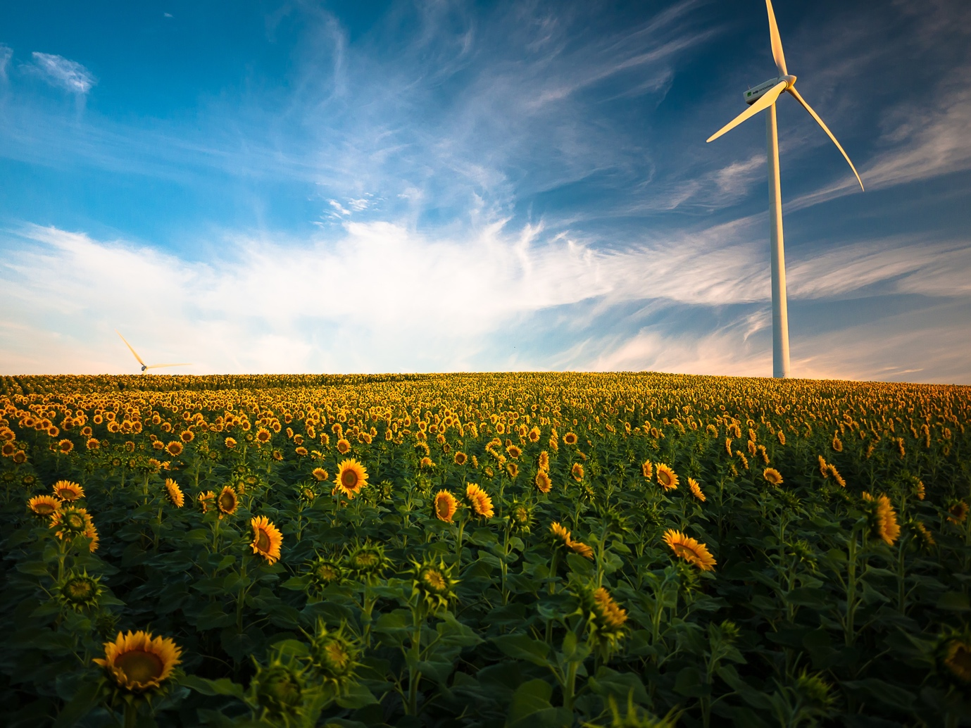

Pic: Gustavo Quepón - UnSplash

