Welcome to September’s newsletter.
This is my first newsletter as Head of Children, Youth and Intergenerational Discipleship, and what a privilege it is to begin by sharing just some of the exciting opportunities, events and resources coming our way in the months ahead.
One of my greatest joys so far has been connecting with our Synod Children and Youth Leads. Time and again, I have been inspired by their creativity, dedication and deep commitment to children, young people and families across the URC. Their passion reminds me that, even in challenging times, God is at work.
I am noticing that across the denomination, faithful people are investing in the next generation, creating spaces where disciples of all ages can grow, belong and thrive together. Thank you for all you do. Your ministry matters, your partnership is valued, and I am excited about what we can achieve together.
Many blessings
Jo
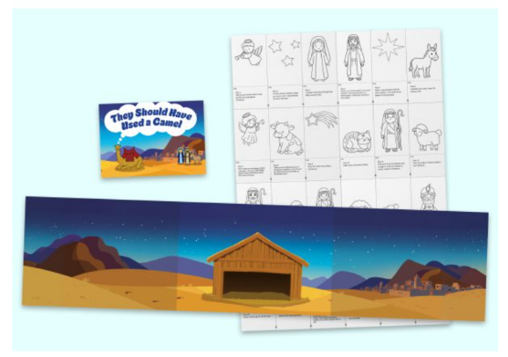
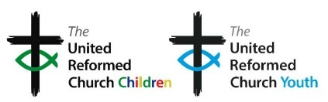
Christmas is fast approaching - the bookshop is now taking orders for the Advent resource. This year’s resource will comprise of an Advent calandar, little characters to colour in, cut out and stand up inside the calandar to create your own nativity. There are suggested activities and questions to help explore Jesus birth aswell as an accompaning humorous story book – They should have used a camel. bit.ly/AdvenT2026

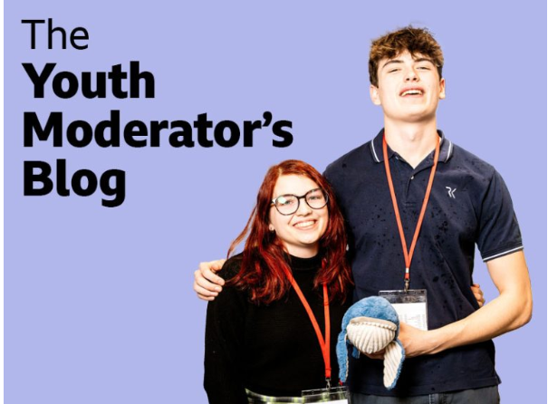

Exciting news – the Youth Mod blog has gone live!
Keep up to date on all goings on youth related around the URC. Save this link to ensure you don’t miss any monthly updates.
bit.ly/ModBlogURC
And here is a direct link to Kacie and Alex’s first post: https://urc.org.uk/overwhelming-welcome-for-mods-on-tour/

LUNDIE MEMORIAL AWARD CELEBRATING CHILDREN AND YOUNG PEOPLE

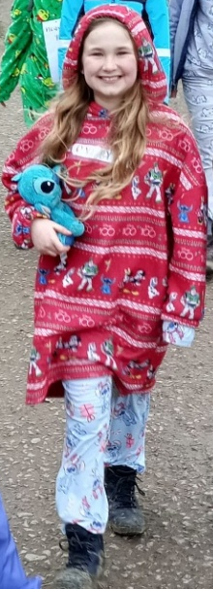

10-year-old Rosie Stone, who was June’s Lundie awardee, was nominated due to her passion about serving God in her local church. She is always lending her talents to services where she’s invited to read Bible stories or give announcements.
Rosie’s idea was to walk 10km in pyjamas to raise funds for OneByOne. https://onebyone.org/our-story/
The plan was to walk twice around Rother Valley Country park at 5km each circular walk. With help from Church members Rosie worked on an advertising poster, she worked hard raising sponsorship for the 10km walk, taking ownership of the event and because of her, to date, £2500 has been raised for OneByOne. Well done Rosie - an inspiration to us all.
Perhaps there is someone in your church who is 25 years or younger who you would like to nominate for this award? Only 30 awards remain so be quick! Details can be found here: bit.ly\URCLundie

********Children and Youth workers conference********

We're planning a national weekend for children, youth and intergenerational workers in the United Reformed Church on 1–3 October 2027.
We want it to be a weekend that equips, encourages and inspires those involved in ministry with children, young people and families.
Your feedback will help shape the location, programme and priorities for the weekend. Thank you for helping us make it the best it can be.
https://docs.google.com/forms/d/e/1FAIpQLSdL_oPRj20Ob249aKiKAJ9r1d4QtV8Ai81UNNc9dGNWtmrQDA/viewform

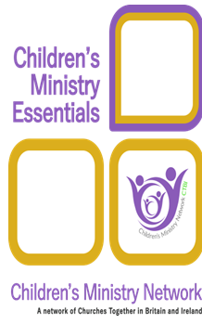
NEW FREE CHILDREN’S MINISTRY TRAINING
Children’s Ministry Essentials is designed for anyone working with children in local churches and consists of 10 modules covering a wealth of topics including child development and spirituality, pastoral care, leadership and teamwork and the role of play. It is designed to deepen your understanding, increase your confidence and develop your skills.
Please watch the video trailer! https://youtu.be/lHGCz8QakFA
Join an online learning group facilitated by our wonderful CYDO+ team. If you are engaging in ministry with children, families or intergenerationally within a URC church or Local Ecumenical Partnership, we are offering free places (normally £80-£100 person). Contact children.youth@urc.org.uk to register your interest and for more details.

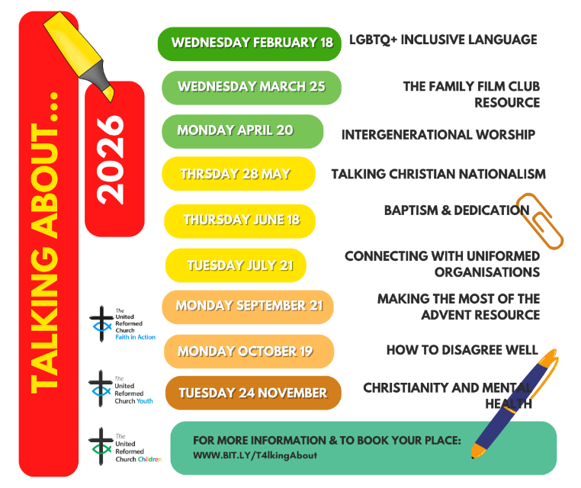

Did you know that most of the talking about sessions can be found on our YouTube channel: https://bit.ly/YTplaylistURC
CANCELLED


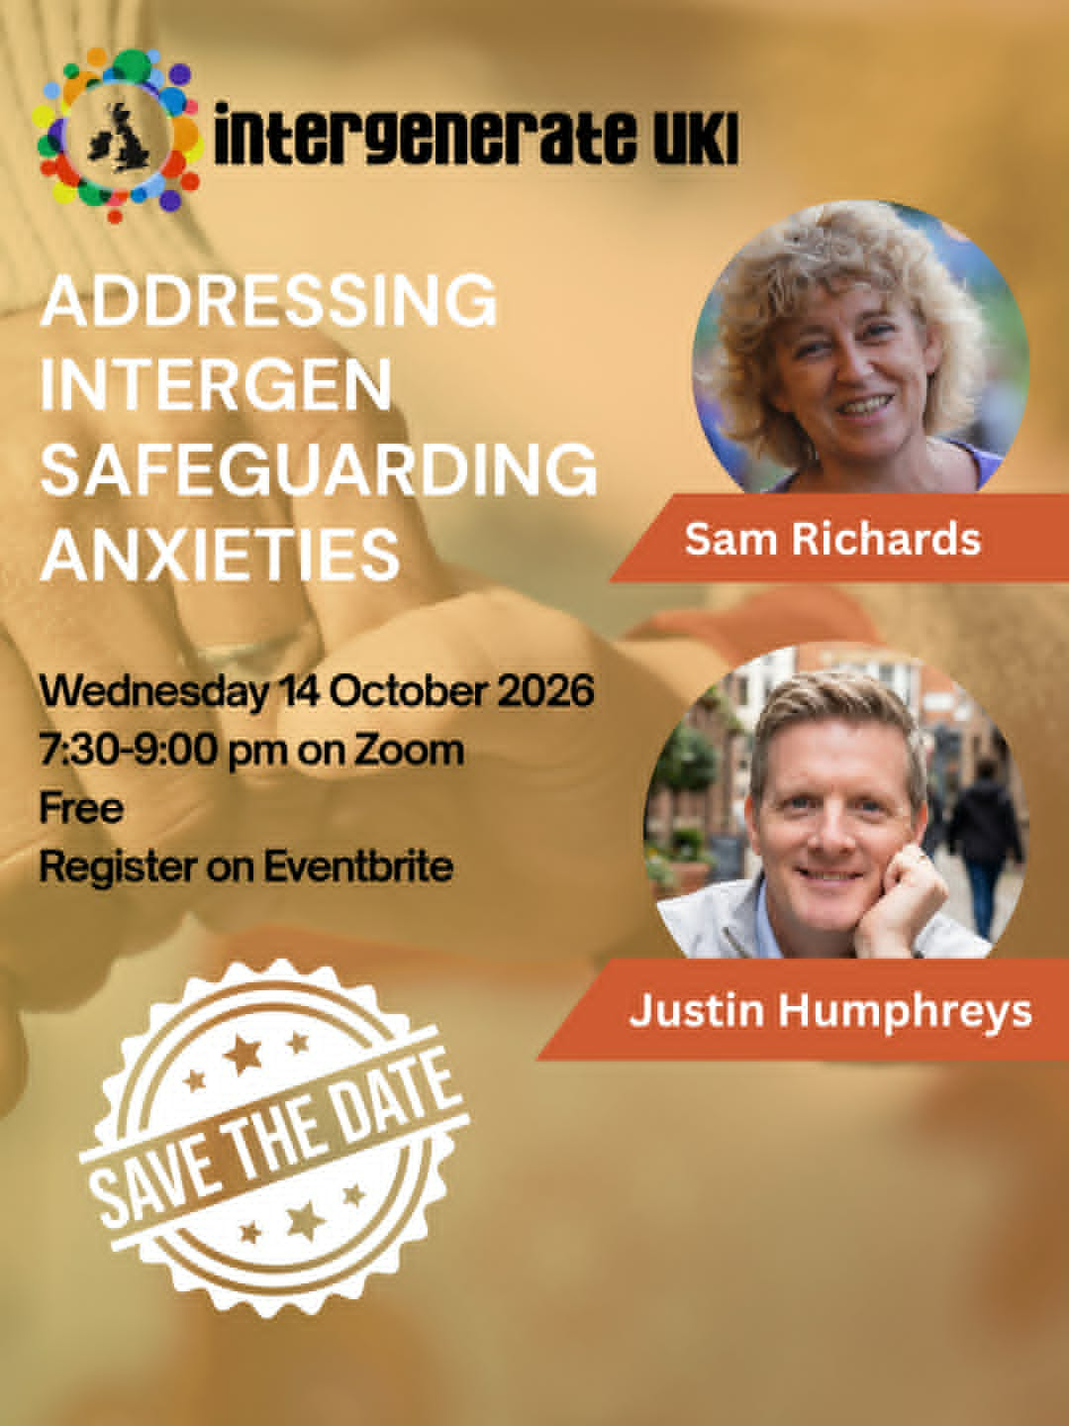
Help Shape Future Resources
What's working well? What's missing? Your experience can help shape resources for children, youth and intergenerational ministry across the URC.
Scan the QR code and complete the survey by 2nd November 2026 and help us create resources that truly meet the needs of our churches: URC Children's, Youth and Intergenerational Resources Survey – Fill in form

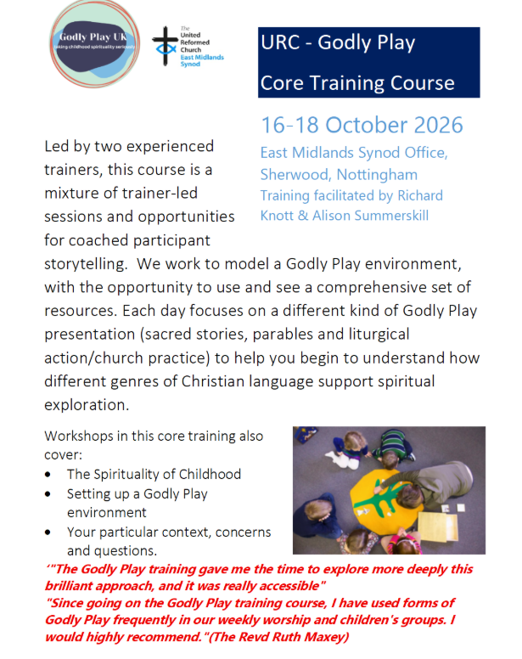

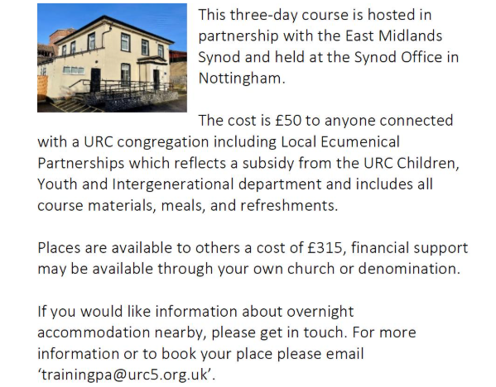

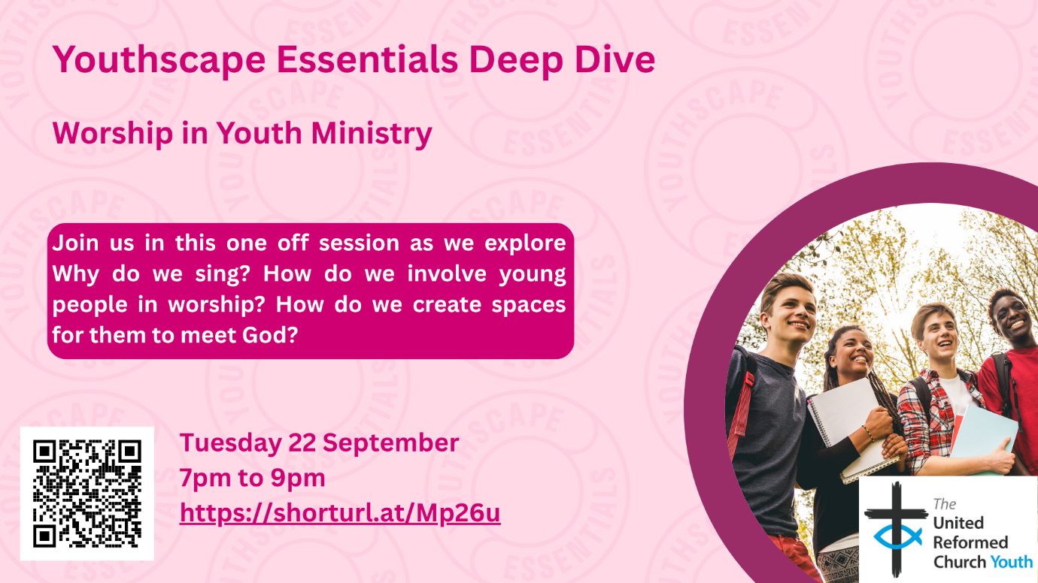

LOOKING AHEAD - for your diaries or your prayers
21 September Talking About…making the most of the advent resource
22 September Youthscape deep dive
14 October Intergenerate UK webinar
16-18 October Godly Play training
19 October Talking About…..how to disagree well
Next Bi-Monthly Update: November 2026
