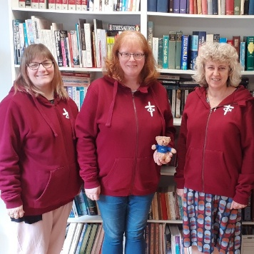
Dear Friends,
Welcome to our new format bi-monthly e-newsletter. We are trialling have a Word version to make it easier for people to copy and paste material into their own newsletters and communications. Do let us know if this is helpful! There is also a PDF version. We are also working on more streamlined communications from the whole Faith in Action team (our new department) so the timing will alter a little to fit this new pattern.
Having said all that hopefully you will find the usual mixture of information about training, resources and inspiring stories to resource you in your work with children and young people.
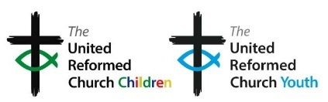
My personal news is that I will be moving on at the end of March, after eight and a half years. Please pray for the process of recruiting my successor to take the work forward in the next season. The job details can be found here: https://urc.org.uk/jobs/

Blessings,

Sam Richards, Head of Children’s, Youth and Intergenerational Discipleship

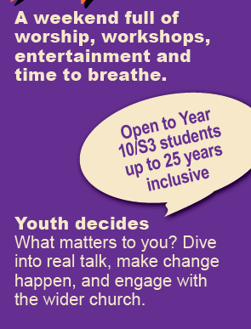

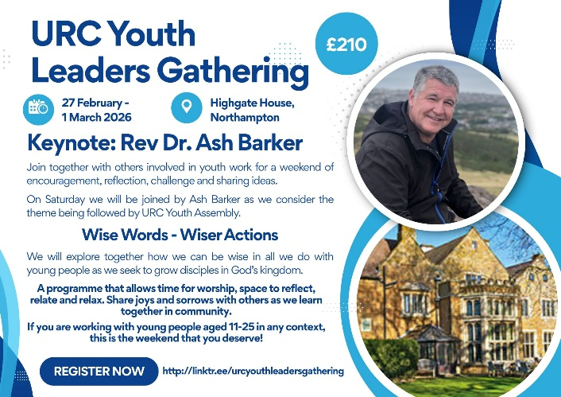

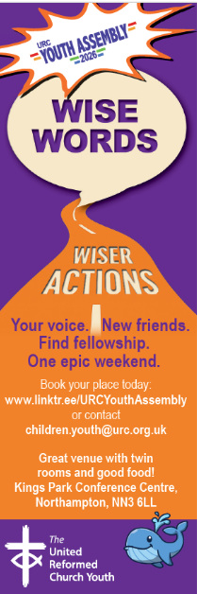
URC Youth Assembly 2026 and URC Youth Leaders Gathering 27 February – 1 March 2026 www.linktr.ee/URCYouth Assembly http://linktr.ee/urcyouthleadersgathering
BOOKINGS CLOSE ON SUNDAY 25 JANUARY 2026 !!!!!
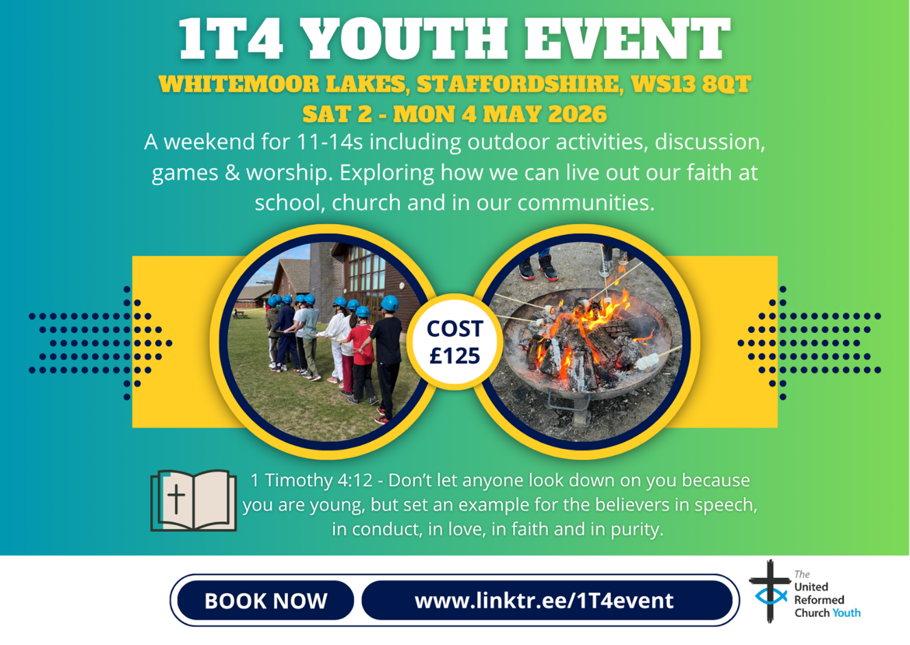
Leaders are welcome to accompany young people that they bring to 1T4
contact children.youth@urc.org.uk for information
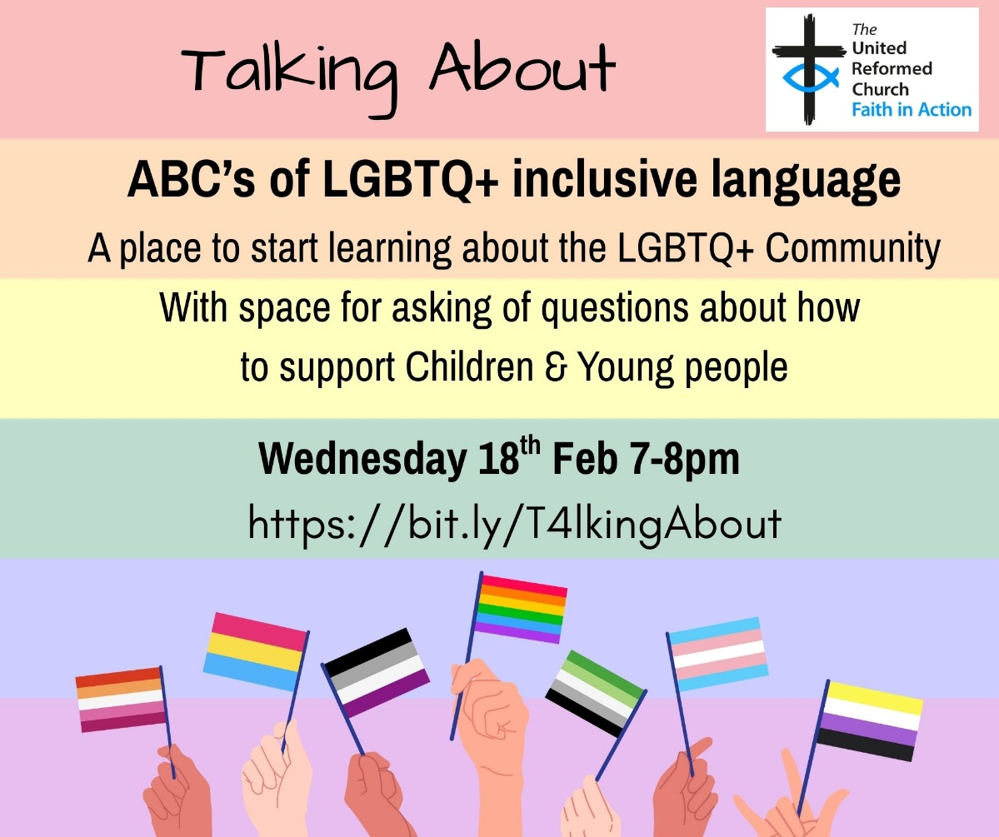


Parade service guidance
We have worked with the URC Guide and Scout Fellowship to produce helpful guidance for churches considering offering a parade service for uniformed groups connected to the church or meeting at their premises. It takes you through the planning process with understanding of the needs of the uniformed groups and how to welcome and involve the children and young people within them. See: Family-friendly church - United Reformed Church
We are also offering small grants of £50 or £100 to enable churches to build their connections with uniformed groups: Children & Youth work grants - United Reformed Church

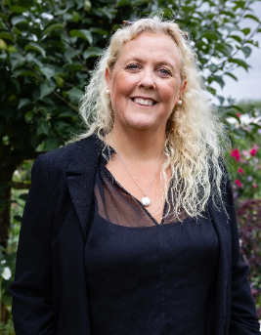
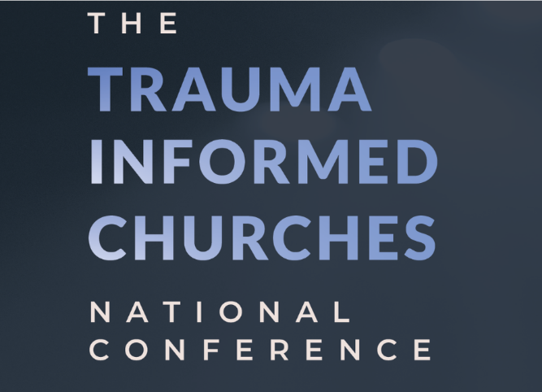
A conference with
a theology of hope
Saturday 18th April 2026
£30 for day conference in Bath.

Betsy de Thierry MBE

More information:
Trauma Informed Churches National Conference — Trauma Informed Churches

Practical ‘How To’ Films for everyone involved in ministry with children, young people and/or young families!

Over thirty bite-sized films are now available from Church of England to support anyone involved in ministry with children, young people, and their families (CYPF). These short videos tackle real-life questions like “How do I start a conversation with a child?” and “How can I support young people’s wellbeing?”
Each film is packed with practical tips, creative ideas, and Biblical wisdom. Whether you're a church leader, volunteer, or simply curious to learn more, you'll find valuable insights to help strengthen and grow your CYPF ministry. Find all of the videos here
An article by Dr Sarah Holmes & Dr Sam Richards has been published in Journal of Values and Beliefs: Do they have the support they need? Illuminating the experiences and perspectives of Christian youth, children and family workers in the UK
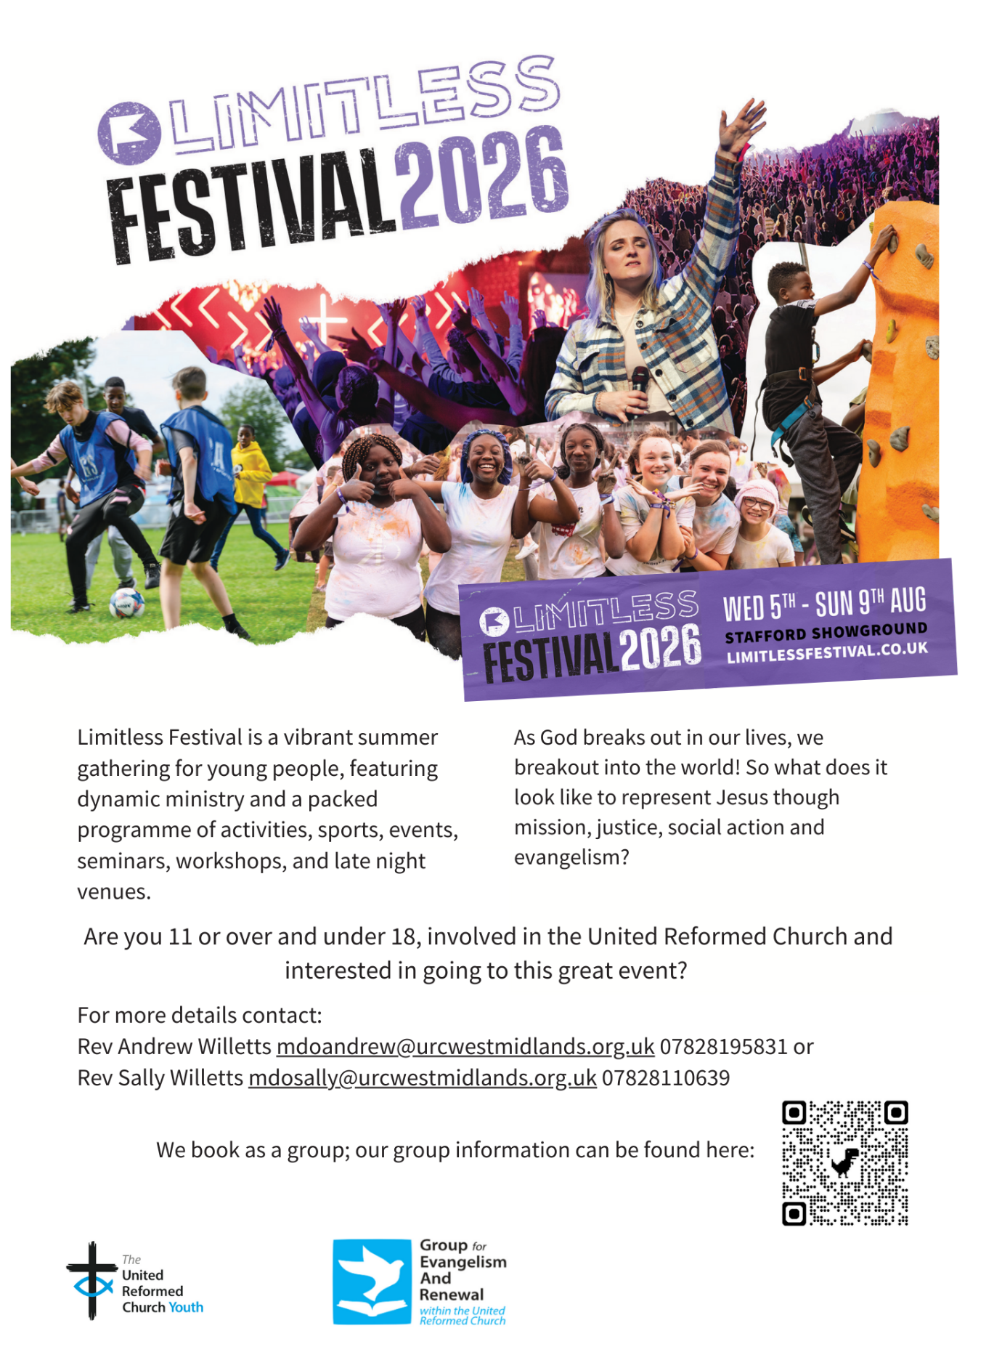


LUNDIE MEMORIAL AWARD CELEBRATING CHILDREN AND YOUTH PEOPLE
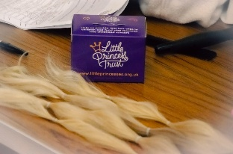

January’s Lundie Award was given to a very courageous member of URC Children. Seven-year-old Francesca Miller donated 20” of her hair to be used to create wigs for others who have lost their hair due to Cancer treatment. Francesca has also fundraised and managed to send £800 along with her hair to the Little Princess Charity. Well done Francesca – what a selfless and act that will benefit others immensely.
INTERGENERATIONAL MINISTRY
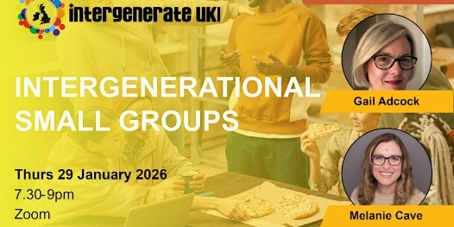
To reflect our ongoing focus on becoming more intergenerational we now have a webpage dedicated to this on the URC website: Children's, youth and intergenerational - United Reformed Church
Free webinar Thursday 29 January 2026 7.30-9pm
Intergenerational small groups with special guests Gail Adcock and Melanie Cave.

Book here
Online conference 24 February 2026 7-10pm $49 individual or $39 student, $99 for church/ministry group
Keynote Josh Packard: What if the most important skill for the future of the church is not better programming, clearer theology or stronger leadership, but deeper listening?
Seminars with Tammy Preston, Dave Csinos, Drew Smith, Melanie Cave, Lynette Hoffman, Dawson Murray, Stephanie Frizt, Paula Montes-Roldan.
https://www.intergenerateconference.com/intergenerate-online-gatherings-registration/global-conference-feb-26
LOOKING AHEAD - for your diaries or your prayers
29 January 2026 Intergenerational small groups webinar
18 February 2026 Trauma informed church day conference
18 February 2026 Talking about…. LGBTQ+ inclusive language
27 February to 1 March 2026 YOUTH ASSEMBLY
27 February to 1 March 2026 Youth Leaders’ Gathering
2 to 4 May 2026 1T4 youth weekend (for ages 11 to 14)
5 to 9 August 2026 Limitless festival
Next Bi-Monthly Update: March 2026

