Welcome (Parents and Carers asked to stay until after the opening Prayer)
Welcome back to Friends on Faith Adventures. We are looking forward to going on a journey and nobody knows where we will end up. All we know is we have got our crate filled with adventure and an open path ahead. So, hold on tight and enjoy the ride!!
Let’s hear about FOFA bear and FOFA cam’s adventures this week and how everyone got on with the Walking the Way challenge. (Encourage everyone, including parents and carers, to join in.)
The Opening Prayer
We are friends together (shake hands with both palms facing towards body)
On a faith adventure (point to forehead with thumb. Hold other hand with palm facing up and bring the side of your first hand down so that it goes across the palm of the second hand just below the fingers)
With the Bible as our mapbook (draw cross with thumbnail on back of hand then put hands together and open like a book)
And Jesus as our guide (use index fingers to point into palm of each hand in turn).
God, be with us in all that we do (point up, then make index finger into a hook shape and move down as though pulling down towards you)
And go with us wherever we go (point outwards).
Amen (two thumbs up with hands apart, bring hands together)

The alternative Prayer
Lord help us to be:
Prepared for adventure
In all we do.
Loving and caring,
Open to others
Together as one community
Sharing the love of Jesus on our way.
Amen

Fun Together
Duck, duck, goose
What you do:
Everyone is to sit in a circle on the floor, one person is chosen and stands up. They move around the outside of the circle, gently touching each person on the head or shoulder (please beware of those who do not like to be touched) and saying ‘duck’. At random they should touch a head/shoulder and say ‘goose’ instead. The person who was touched then stands up and runs round the circle clockwise while the other person runs anticlockwiseround the circle, each trying to be the first one back to the space left in the circle. The first one back sits down, leaving the other to start again, going round the circle, gently touching heads/shoulders, etc

Blindfolded route
What you will need:
Blindfold
A simple obstacle course using chairs

Lay out a rather simple obstacle course, perhaps one with chairs as obstacles. Be aware of trip hazards.
Blindfold a member of the group and ask them to feel their way across the course while a chosen friend calls out helpful instructions. At the same time the rest of the group is to shout out false instructions. The blindfolded person needs to filter out the voices and head for the end of the course, following only the words of the person they trust. Encourage the blindfolded person to go at a slow pace to stay safe. All other participants can shout from the side-lines, but they are not to touch the blindfolded person or the obstacles on route.

It would have been easy for the person in today’s story to listen to other people’s voices rather than God’s but they filtered them out and keep trusting and believing in their God.

Today’s theme is about how we can stay devoted and trusting in God even when others around us are trying to tell us otherwise. T
The Big Story- 1 Kings 18: 19-39 – Believe
In today’s story you will need to split the group into 2. One side are the prophets of Baal and the other side represents Elijah and his people.
When the word Baal is said, the prophets of Baals are to dance on the spot and say ‘Baal, answer us’.
When the word Elijah are said, those representing Elijah are to raise their hands to the sky and say ‘pray louder’.
At the end, all say ‘The Lord is God’ together.

There was man named Elijah who was sent by God to speak to some followers, or prophets, of the god Baal.
Elijah called all the prophets of Baal and others to Mount Carmel. He said to them, “you have been trying to follow both the Lord our God and the god Baal. This cannot continue. You’ve got to choose which is true.“
Elijah said, “if you truly believe in your god, then pray hard to them, pray hard to Baal.”
The people were silent. Elijah continued, “I am one prophet but yet there are more than 400 prophets of Baal.”
“Bring me two bulls,” Elijah said. He told the prophets of Baal to chose one of them and to prepare it as a sacrifice to their god.
The prophets of Baal did just this: they cut the bull into pieces, made a big fire from wood and put the meat on it.
Elijah took the other bull.
Then Elijah said to the prophets of Baal, “Do not start the fire yourself but pray to your God to start the fire.”
The prophets of Baal took on the challenge and prayed day and night for their God to start the fire, but nothing happened. Elijah laughed and jeered at them and told them to pray louder………the prophets of Baal continued to pray but it was hopeless, nothing happened.
Elijah laughed some more and asked if Baal had gone travelling, or perhaps was sleeping or thinking as still nothing happened.
So Elijah took twelve stones and placed them on the ground to make an altar to the Lord. He placed some wood on top and cut up the meat of the bull into pieces and put those on the altar too. Then he ordered some water to be poured on the meat and wood, not once but three times. The water overflowed.
The prophets of Baal looked on confused.
When evening came, Elijah prayed to God: “Lord, you are the God of Abraham, Isaac and Israel. I ask you now to prove that you are the God of Israel. And prove that I am your servant. Show the people of Baal that you commanded me to do all these things. Lord, answer my prayer. Show these people that you, Lord, are God. Then the people will know that you are bringing them back to you”
Then fire from God came down, it burned the wood, it burnt up all the water and it cooked the meat.
When the prophets of Baal and all the other people saw this, they knew that there was only one true god. They shouted, ‘The Lord is God’
Elijah looked on at all the people, I wonder what he must have been thinking to himself?

Creative Adventure.
What you’ll need:
Pale coloured stones/ small pebbles https://www.bakerross.co.uk/white-painting-stones
Permanent marker pens/ paints
Pva glue
Brushes

What to do:

Spend a few moments discussing how you could decorate your stone. Suggest words/ pictures/ expressions. (faith/ believe/ devotion/ in God we trust)
Use the marker pens or the paint to decorate the stone.
Once dry (you could use a hairdryer to speed this up), brush some pva over the picture to create a seal. This will allow the stone to be put outside. Encourage the group to display their stone somewhere they will see it most days as a reminder to put God first and that God can be trusted.

Wondering questions to use during creative time:
I wonder why the prophets couldn’t decide between God and Baal?
I wonder if there is ever a time when you need just to believe?
I wonder how you would feel if you were Elijah?

The Adventure Map
Explain the Adventure Map and how a lot of the books were written hundreds and thousands of years before Jesus came to Earth. However, a lot of the stories in the Bible before the birth of Jesus, talk of his coming and set out how God wants us to live our lives.
Take the group to the Adventure Map that you have created on the wall. Get the group to find where on the Map today’s story came from. Choose one or some of the things created by the group to be photographed and attach this to the wall to create a visual reminder of where the story came from and your adventure together. The aim is that in a year you will have lots of reminders of the stories and where in the Bible they come from. Use a piece of string or ribbon to connect the photo of the craft work to the book of the Bible.

Walking the Way
This is a time to invite the parents and carers back in to share what the children have been up to during the session. They will also be here to hear about the Walking the Way challenge and the tasks (should they choose to accept them) that the children (and parents) are about to undertake.
For the Younger: FOFA the bear
This is FOFA. FOFA likes nothing more than to go on an adventure; FOFA is a little more adventurous than me. FOFA believes that faith is a journey and that’s why FOFA would love to take you on a journey with him and walk the way of God in our everyday lives. Each session FOFA would like to go home with one of you and add to FOFA’s scrapbook of things you do together. FOFA doesn’t mind if you draw a picture of what you have done, take a photograph or just write a story about it. FOFA also doesn’t mind if you just come and tell the rest of us what you got up to together. But because FOFA’s memory isn’t very good as FOFA’s brains are made of stuffing, it would be better to save the memories in the book if you can. At the end of our time together we can always remember the great adventures we have been on together with FOFA and hopefully you will walk a little closer with God.
For the Older: FOFA cam
This camera is your window on the world. You have one shot at this, so choose carefully. You will be given a very precious piece of equipment – a FOFA cam. You have one photo to take with the camera, that records one thing – a way you have met the challenge. If there are other people in the photo, please ask their permission first and explain this photo will be put on display here. Bring back the camera and your photo next time to share your moment - and remember you only have ONE shot at this!
Every time we will choose someone to take FOFA bear and someone to take FOFA cam to help them with the challenge – but we can all have a go at the challenge!
Our Walking the Way Challenge this time is: To find and do a five minute daily devotional for a week (longer if you can) You can find devotionals online https://kidscorner.net/devotions or in books. You may instead decide on a bible book to read a little of each day. Here is a link to some online devotionals provided by the URC: https://devotions.urc.org.uk/todays-daily-devotion/

Adventurers Go!
So today we heard that that we are to not put any other gods before our God. Even when those around us are tempting us away from God, we can remain trusting and devoted. God will not leave us.

Prayers (choose one/both)
Prayer
The leader is to say a line of words and then the group to repeat after them:
Loving God……… Loving God
We can stay devoted to you……….. We can stay devoted to you
We know you are always with us……… We know you are always with us
You never leave us…………… You never leave us
When we call, you answer…….. When we call, you answer
Amen…… Amen

Active Prayer
What you need:
Note paper
Pens/ pencils
Examples of emojis or allow to use phones to access them (you may find the image on an additional page useful)

Encourage the group to write their own emoji prayer to God. Explain to the group that a prayer to God can take the form of a devotion, expressing our love and feelings. We often use emojis to do this with our friends and family.

End Prayer Every Session: Altogether
We are Friends on Faith Adventures, travelling together with God.
Adventurers go! Amen

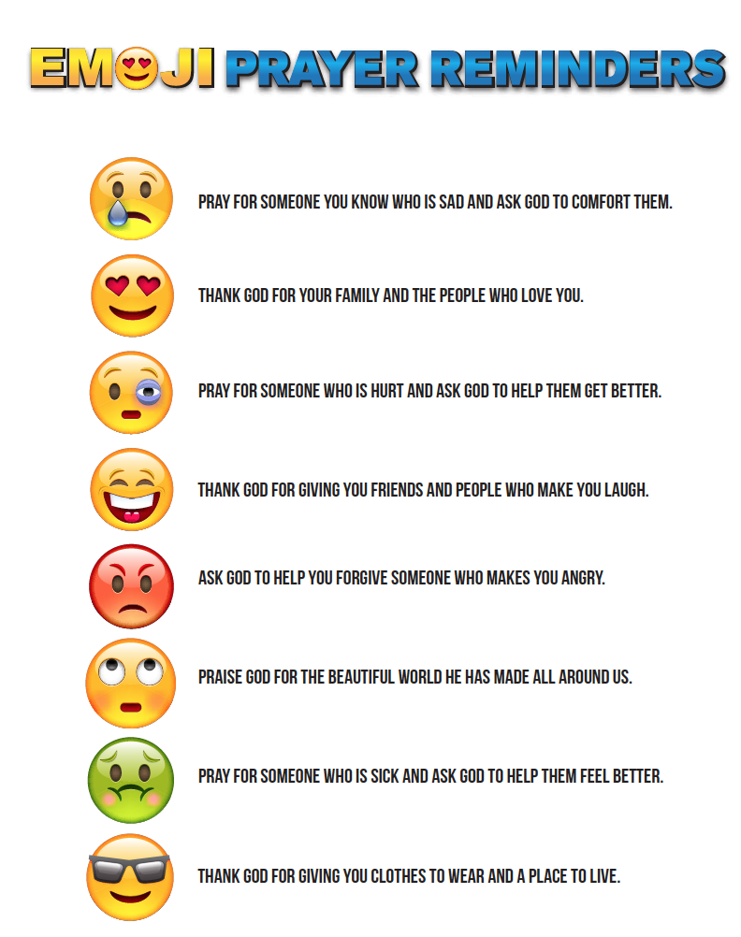

From
childrens-ministry-deals.com
Location | Possible hazard | Action required | Action taken | Signature
During session | Risk of injury when playing duck, duck, goose | Adults to supervise. Ensure all wearing sensible footwear
During session | Risk of injury when playing blindfold game | Adults to supervise. Ensure all keep to the rules, intervene if necessary.
During session | Mark clothes with permanent marker pen | Wear old clothes/ apron. Warn the group

What you will need:
Game:
Blindfold
A simple obstacle course using chairs
Story:
Craft:
Pale coloured stones/ small pebbles https://www.bakerross.co.uk/white-painting-stones
permanent marker pens/ paints
Pva glue
Brushes
Prayer:
Note paper
Pens/ pencils
Examples of emojis or allow to use phones to access them (you may find the image on an additional page useful)

