Many children are passionate about the environment and want to engage with the churches journey towards becoming an Eco church.
Think – a moment to reflect or a story to inspire.
Do – a simple task to perform
Do more – a list of points for further study and action, with links to all sorts of helpful resources that are available online from a variety of different organisations.

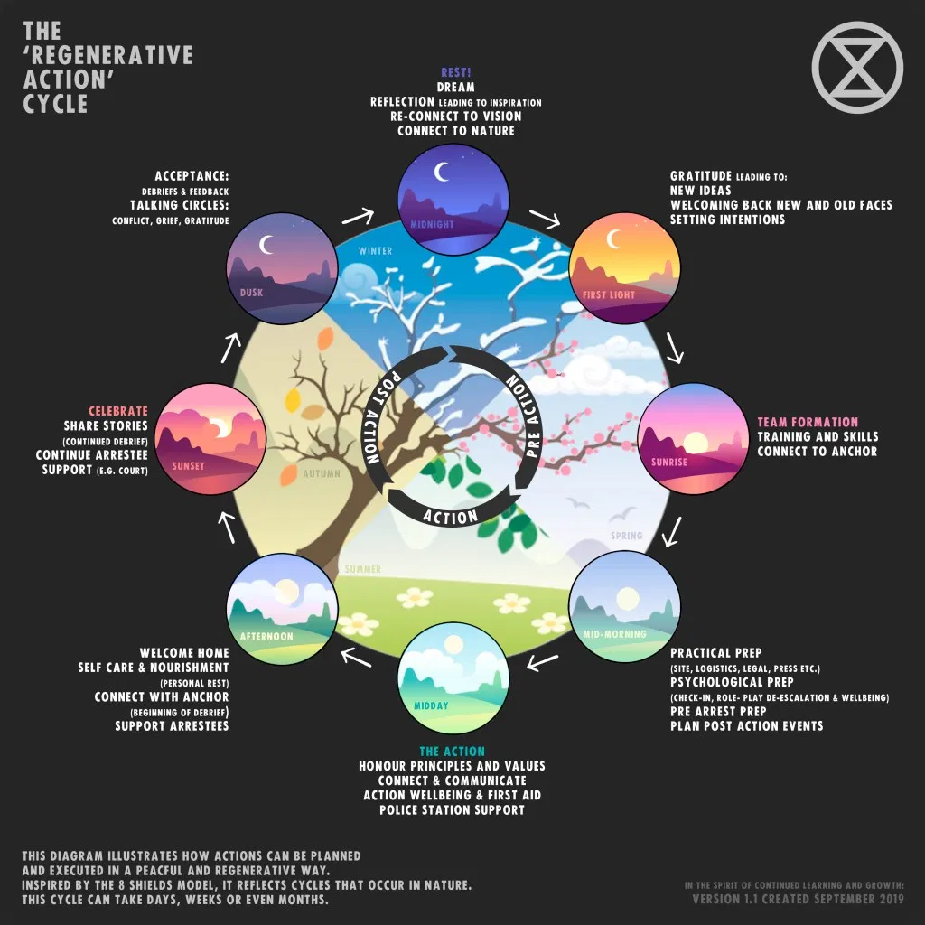

Worship and teaching
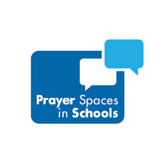

Prayer spaces in schools and Christian aid. These organisations have joined together to create some lovely prayer space ideas. https://www.christianaid.org.uk/schools/prayer-spaces-schools

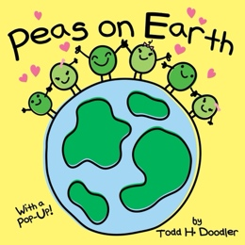
Peas On Earth by Todd H. Doodle. Peas on Earth uses a simple play on words to portray the basic concepts of peace, harmony, getting along with all kinds of people, and being green.
https://youtu.be/DbpzwsvCCbM

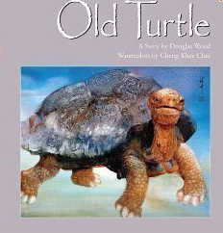
Old Turtle and the Broken Truth: by Douglas Wood. The world is a beautiful place, filled with luscious trees and flowers and a wide variety of creatures. They all begin arguing over who God is. Before it develops into a big argument, Old Turtle offers her wisdom and view of the future. There is peace again, until God adds people to the earthly creatures, and they (we) go through the same argument - whose definition of God is the accurate or better one. The people argue, hurt each other, wars break out. Old Turtle comes to the rescue again. Diversity, God as in all of us - a wonderful book!
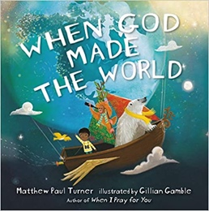
When God Made the World: by Matthew Paul Turner. If you are looking for a different kind of creation book, this may be it, it focuses on the complex way that God created our vast and scientifically operating universe, including the biodiversity of life on our planet and the intricacies of a vast solar system.

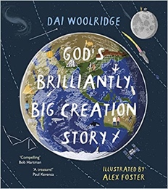
God's Brilliantly Big Creation Story: by Dai Woolridge
Beautiful to look at and entertaining to read, this is a picture book to inspire awe and amazement in children for the world around them and for the God who created it.
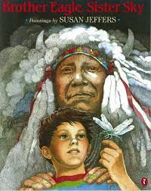

Brother Eagle, Sister Sky - A Message from Chief Seattle: by Susan Jeffers. The Earth does not belong to us. We belong to the Earth. The great American Indian Chief Seattle spoke these words over a hundred years ago. His remarkably relevant message of respect for the Earth and every creature on it has endured the test of time and is imbued with passion born of love of the land and the environment.

Buildings
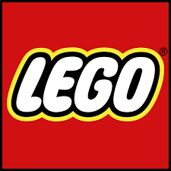
Lego Buildings Using Lego as inspiration consider how to create an environmentally building. What would you include and how can you improve it to make it more energy efficient.

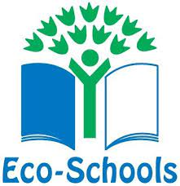
Eco Schools have lots of information on Energy efficiency why not use this to help your churches. https://www.eco-schools.org.uk/ten-topics/energy/

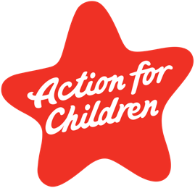
Action for Children. Learn more about how to be more energy efficient. Action for Children offers lots of information on this for your home, much of it can be used in churches too. https://parents.actionforchildren.org.uk/behaviour/using-rules-rewards/saving-energy/
Some fun facts on energy saving https://www.thegreenage.co.uk/15-surprising-energy-facts/
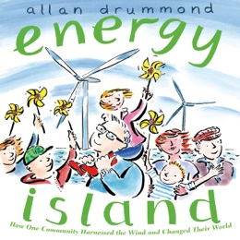

Energy Island: How One Community Harnessed the Wind and Changed Their World (Green Power): by Allan Drummond. This is an inspiring upbeat true story of how one Danish Island converted to 100% renewable energy in just ten years, the story is told in a child-friendly way.

Earth Hour - Earth hour activity packs for children. https://www.wwf.org.uk/get-involved/schools/school-campaigns/earth-hour-schools

Land
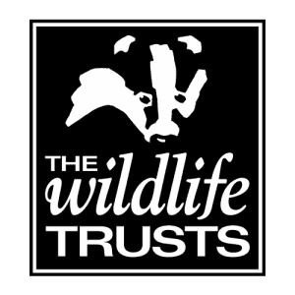
Wildlife trust lots of info about gardening and how to encourage wildlife into your garden.- https://www.wildlifetrusts.org/gardening

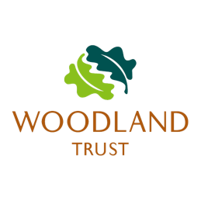

Woodland trust This website gives lots of ideas about plants and wildlife, how to identify them and all sorts of other information. https://www.woodlandtrust.org.uk/trees-woods-and-wildlife/plants

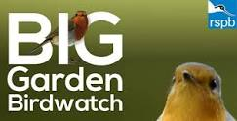
Big garden birdwatch, https://www.rspb.org.uk/get-involved/activities/birdwatch/everything-you-need-to-know-about-big-garden-birdwatch/

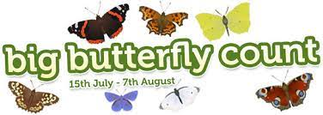
Big butterfly count https://bigbutterflycount.butterfly-conservation.org

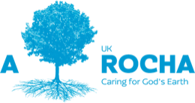
This video is a beautiful example of caring for God’s creation from Arocha, https://www.youtube.com/watch?v=8i5NdNs8HaU&t=572s
Look at their website for lots of other ideas to help you on your Eco journey. https://arocha.org.uk

Community and Global Engagement

Christian Aid.
https://www.christianaid.org.uk/sites/default/files/2019-04/Fumes-or-Futures-chatterbox.pdf
https://www.christianaid.org.uk/sites/default/files/2019-04/Fumes-or-Futures-poster-A4.pdf
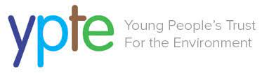

The young people’s trust for the environment https://ypte.org.uk/factsheets

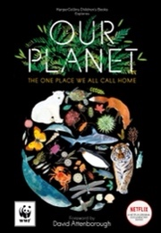
Our planet: The official children’s companion to the Netflix documentary series with special foreword: by David Attenborough. Lose yourself in icy landscapes, dense jungles, and endless oceans. Learn how our fascinating habitats, and the plants and creatures living there, interconnect to create the one place we all call home – Our Planet.
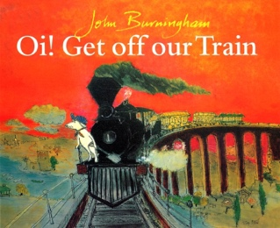
Oi! Get Off Our Train: by John Burningham A little boy sets off on a round-the-world night train to dreamland with only his toy dog for company. But soon all sorts of endangered animals are asking if they can jump up and join them on their journey.

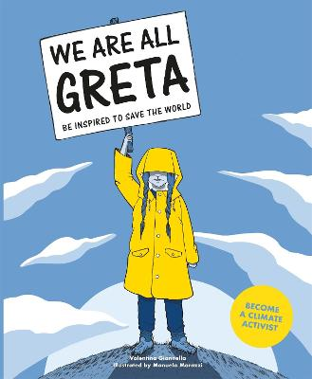
We Are All Greta: by Valentina Giannella, is a tool that will enable readers to understand the climate emergency and learn what can be done to help.

Lifestyle
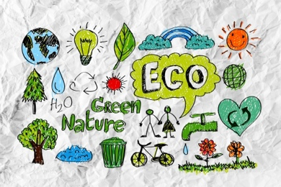
8 Eco-Friendly Activities to do with Children by Fiona Mckenzie Johnston https://eco-age.com/resources/8-eco-friendly-activities-do-children/
Why not explore some of these activities to do with the children and young people at your church?
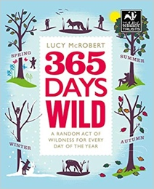
365 Days Wild: by Lucy McRobert. A Random Act of Wildness is any little thing that you can do as part of your day, to enjoy nature. It can take a few seconds – like smelling a wildflower on the way to work; or a few hours – like creating a whole area for wildlife in your garden. Some Random Acts of Wildness don’t take any time at all, but instead are little changes to your daily routine that will ultimately be better for wildlife, like buying a reusable coffee cup.
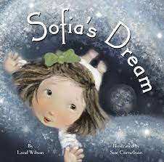
Sofia's Dream by Land Wilson. Sofia befriends the Moon and sets off on a dreamy adventure to visit her friend. She sees our planet from the Moon's point of view and is inspired to do whatever she can to protect our Earth. When she wakes, Sofia encourages others to do the same.
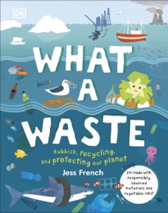
What A Waste: Rubbish, Recycling, and Protecting our Planet: by Jess French
In this informative book for children, you will find everything you need to know about our recycling and our environment. The good, the bad, and the incredibly innovative. From pollution and litter to renewable energy and plastic recycling.

