Welcome (Parents and Carers asked to stay until after the opening Prayer)
Welcome back to Friends on Faith Adventures. We are looking forward to going on a journey and nobody knows where we will end up. All we know is we have got our crate filled with adventure and an open path ahead. So, hold on tight and enjoy the ride!!
Let’s hear about FOFA bear and FOFA cam’s adventures this week and how everyone got on with the Walking the Way challenge. (Encourage everyone, including parents and carers, to join in.)

The Opening Prayer

We are friends together (shake hands with both palms facing towards body)

On a faith adventure (point to forehead with thumb. Hold other hand with palm facing up and bring the side of your first hand down so that it goes across the palm of the second hand just below the fingers)

With the Bible as our mapbook (draw cross with thumbnail on back of hand then put hands together and open like a book)

And Jesus as our guide (use index fingers to point into palm of each hand in turn).

God, be with us in all that we do (point up, then make index finger into a hook shape and move down as though pulling down towards you)

And go with us wherever we go (point outwards).

Amen (two thumbs up with hands apart, bring hands together).

Alternative Prayer
Lord help us to be: Prepared for adventure In all we do.
Loving and caring,
Open to others
Together as one community
Sharing the love of Jesus on our way. Amen

Fun Together
You will need:
- Lots of toilet rolls
- 4 cups of water
Split the group into up to 4 teams and get each team to nominate an “injured person”. Get the injured person to stand on the other side of the room from the rest of the group. Give each member of the group a toilet roll (bandage), and one member a glass of water.
The aim of the game is for each member, in turn, to run over to the injured person and wrap them in ‘bandages’ from head to toe and then send the next one until all toilet rolls are used. Then send one member with the water and help the injured person to drink the water. Finally (if appropriate) get the team to carry the injured person back to the starting point. The one that gets there first wins.

The theme of this session is being a good neighbour.

The Big Story: The Good Foreigner Luke 10
Required in the bag:
- A shoulder bag
- An old shirt that can be ripped (Make little cuts in the shirt to make it rip easier)
- Rolled up newspapers
- A sash
- A priest’s collar made of card/plastic
- Plasters and bandage
- A cushion and blanket
- A bag of money
[You will need upto 8 volunteers: the Traveller, the Samaritan, three Robbers, the Priest, the Levite and the Inn-Keeper.]
Reader 1: So today we are looking at a story that Jesus used when a clever man tried to trick him by asking how he can get to heaven. Jesus said that he should love God and love your neighbour as you love yourself.
Reader 2: Well, that seems pretty simple.
Reader 1: Yeah, but the man asked who his neighbour was.
Reader 2: Well, that is easy - it is the person living next door to you.
Reader 1: Kind of, but Jesus meant a bit more than just them and he used this story to explain what he meant. There was once a traveller that was going on a journey from Jerusalem to Jericho.
[Get a child to be the traveller and put the shirt on them]
Reader 2: Wow, that has to be a good two-day walk.
Reader 1: Exactly! It wasn’t always the safest thing to do and unfortunately for this traveller, they weren’t lucky.
Reader 2: This doesn’t sound good.
Reader 1: No, the traveller was jumped on by a gang of thieves, who beat them, tore their clothes and took all their belongings and money.
[Get three of the children to pretend to be Robbers and to jump on the Traveller with the rolled-up papers (one of the Readers can tear the shirt, get the Traveller to lie on the ground.]

Reader 2: Oh dear, that doesn’t look good…
Reader 1: So, the traveller was lying there really hurt, when a priest walked by.
[Get a young person to be the Priest and put a collar on them]
Reader 2: Yay, someone to help them!
Reading 1: You would think so, but the Priest just walked by and left them there. Reader 2: No, well, that’s not right.
Reader 1: Then there was a Levite - they were the men that helped in the temple - that walked by.
[Get one of the young people to be the Levite, put sash on the young person.]
Reader 2: Well, if they help in the Temple, a Levite would surely help the Traveller then. Reader 1: Yes, you would think so, but again he left the Traveller just like the priest had. Reader 2: What is wrong with these people, why don’t they help them?
Reader 1: Hold on, there was another person travelling the same road, but they were a foreigner, a migrant, a Samaritan – who was often treated badly and hated for being different.
[Get one of the young people to be the Samaritan (on a donkey – another young person?)]
Reader 2: So, they weren’t going to help either, were they?
Reader 1: It wasn’t very likely. But you know what - they did stop and help. The Samaritan got off the donkey, patched up Traveller’s wounds and carried them on the donkey.
Reader 2: Hold on, the traveller’s wounds haven’t been sorted!
[Take the plasters and stick them all over the Traveller’s face/arms. hands.] *Make sure the Traveller
isn’t allergic to plasters*
Reader 1: So, the Samaritan took the Traveller to the nearest inn, and paid the Inn-Keeper to look after them and paid for all they needed. The Samaritan left saying they would be back in a few days later to pay any other costs.
[Get the Samaritan to give the Inn-Keeper a bag of money and the Inn-Keeper to check if there is enough.]
Reader 2: Wow, that Samaritan was really nice!

Reader 1: When Jesus finished telling the story, he asked the person that was trying to trick him, which one of the three passers-by might have been the Travellers neighbour, and the trickster said that it was the one who showed compassion and stopped to help. So, Jesus told him to go and do the same.
Reader 2: I wonder who we should be good neighbours to?

Creative Adventure What you will need:
- Printed out templates on card or paper
- Red sharpies/felt tip pens
- Small packs of tissues
- A large packet of plasters (enough for three for each child)
- Wrapped sweets
- Scissors
- Sharpies/Felt tip pens
- Sellotape/Stapler
Use the template and print on to card. Cut, fold and stick the cut out into the shape of a doctors’ bag. Draw a red cross on the front to indicate the doctor’s profession. Get the young people to write ‘Love your neighbour as yourself’ on the other side of the bag. Place a pack of tissues, a plaster and a few sweets in the bag. Suggest that the young people give out the sweets as a part of this session’s task telling the story.

Wondering questions to use during creative time:
I wonder who has ever been a good neighbour to you and helped you?
I wonder when you have been a good neighbour to someone you didn’t know?
I wonder who do you find very hard to be kind to and help?

The Adventure Map
Explain the Adventure Map and how a lot of the books were written shortly after Jesus’s time. They tell us about what Jesus said and did and how his friends lived their lives, sharing with others how to be good followers of Jesus.

Take the young people to the Adventure Map that you have created on the wall. Get the children to find where on the Map today’s story came from. Choose one or some of the things created by the children to be photographed and attach this to the wall to create a visual reminder of where the story came from and your adventure together. The aim is that in a year you will have lots of reminders of the stories and where in the Bible they come from. Use a piece of string or ribbon to connect the photo of the craft work to the book of the Bible.

Walking the Way
This is a time to invite the parents and carers back in to share what the children have been up to during the session. They will also be here to hear about the Walking the Way challenge and the tasks (should they choose to accept them) that the children (and parents) are about to undertake.
For the Younger: FOFA the bear
This is FOFA. FOFA likes nothing more than to go on an adventure; FOFA is a little more adventurous than me. FOFA believes that faith is a journey and that’s why FOFA would love to take you on a journey with him and walk the way of God in our everyday lives. Each session FOFA would like to go home with one of you and add to FOFA’s scrapbook of things you do together. FOFA doesn’t mind if you draw a picture of what you have done, take a photograph or just write a story about it. FOFA also doesn’t mind if you just come and tell the rest of us what you got up to together. But because FOFA’s memory isn’t very good as FOFA’s brains are made of stuffing, it would be better to save the memories in the book if you can. At the end of our time together we can always remember the great adventures we have been on together with FOFA and hopefully you will walk a little closer with God.
For the Older: FOFA cam
This camera is your window on the world. You have one shot at this, so choose carefully. You will be given a very precious piece of equipment – a FOFA cam. You have one photo to take with the camera, that records one thing – a way you have met the challenge. If there are other people in the photo, please ask their permission first and explain this photo will be put on display here. Bring back the camera and your photo next time to share your moment - and remember you only have ONE shot at this!
Every time we will choose someone to take FOFA bear and someone to take FOFA cam to help them with the challenge – but we can all have a go at the challenge!
Our Walking the Way Challenge this time is: think about what you would do, if you saw someone needing help. What act of act of kindness could you do?

Adventurers Go!

Today we have heard how we should love others as we love ourselves. God wants all people to be treated fairly, with love and care, no matter how hard that might be. So, as we go out today - remember to try and live out Jesus’ love in all we do and all we meet.

Prayers (choose one/both)
Dear God
In your bible story today, you had a message for us about love Help us to be kind and caring to all
Even those people we don’t really like Because we know that you love them too. Amen
Active Prayer
Draw the outline of a person on a large piece of paper.
Get the children to take two of their three plasters out of their doctors’ bag. Open the plasters to write on:
Plaster 1: Write the name/situation/prayer on the plaster to ask for God’s help. (Get the children to
stick the plaster on the body outline.)
Plaster 2: Write the name of someone that you are going to try and be extra kind to this week. (Get the children to stick the plaster on the body outline.)

Amen

End Prayer Every Session: Altogether
We are Friends on Faith Adventures, travelling together with God. Adventurers go! Amen

What you need for this session Game
- Lots of toilet rolls
- 4 cups of water

Drama
- A shoulder bag
- An old shirt that can be ripped (Make little cuts in the shirt to make it rip easier)
- Rolled up newspapers
- A sash
- A priest’s collar made of card/plastic
- Plasters and bandage
- A cushion and blanket
- A bag of money

Craft
- Printed out templates on card or paper
- Red sharpies/felt tip pens
- Small packs of tissues
- A large packet of plasters (enough for three for each child)
- Wrapped sweets
- Scissors
- Sharpies/Felt tip pens
- Selotape/Stapler

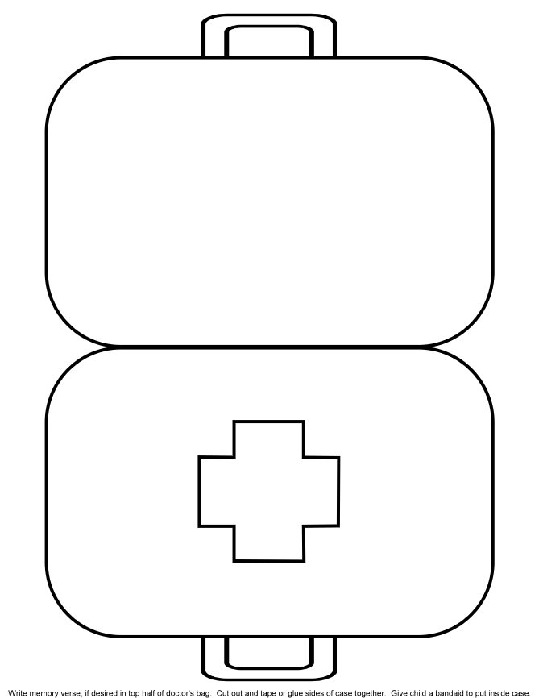

Location | Possible hazard | Action required | Action taken | Signature
During session | Use of plasters in the sketch possible allergic reaction | Check for plaster intolerance with children | Check consent forms and ask participant if they are intolerant
During session | Use of sharpies and possible damage to clothes | Consider offering protective clothing | Offer children protective clothing and warn older children of the indelible nature of the pens.
During session | Use off scissors possible cutting of hands | Use rounded end scissors or closely supervise young children | Allocate a helper to the younger children or get an adult to do the cutting
During session | Possibility of carrying young person | Assess the physical ability of the young people to carry someone | Only allow children that you are confident in being able to carry another child
During session | Possibility of the use of a stapler | Use by adults only or closely supervise for older children | Allocate a helper to the older children or get an adult to do the stapling
Before Session | Possible allergy to certain sweets | Check consent forms for dietary requirements | Only purchase sweets that are suitable for ALL young people to avoid possible

