Welcome (Parents and Carers asked to stay until after the opening Prayer)
Welcome back to Friends on Faith Adventures. We are looking forward to going on a journey and nobody knows where we will end up. All we know is we have got our crate filled with adventure and an open path ahead. So, hold on tight and enjoy the ride!!
Let’s hear about FOFA bear and FOFA cam’s adventures this week and how everyone got on with the Walking the Way challenge. (Encourage everyone, including parents and carers, to join in.)
The Opening Prayer
We are friends together (shake hands with both palms facing towards body)
On a faith adventure (point to forehead with thumb. Hold other hand with palm facing up and bring the side of your first hand down so that it goes across the palm of the second hand just below the fingers)
With the Bible as our mapbook (draw cross with thumbnail on back of hand then put hands together and open like a book)
And Jesus as our guide (use index fingers to point into palm of each hand in turn).
God, be with us in all that we do (point up, then make index finger into a hook shape and move down as though pulling down towards you)
And go with us wherever we go (point outwards).
Amen (two thumbs up with hands apart, bring hands together)

The alternative Prayer
Lord help us to be:
Prepared for adventure
In all we do.
Loving and caring,
Open to others
Together as one community
Sharing the love of Jesus on our way.
Amen

Fun together
This section is for a game. List what equipment is needed for the game first. Then explain the game clearly, step by step. Refer to ‘the children’, ‘the group’, ‘the child’, ‘the leaders’.
Please do not split teams into boys and girls.
Four Corners: A good game to burn off energy!
Label the four corners Moon, Stars, Wheat, Cows (These could be words, pictures stuck up or just verbalised) Pick random corners for the children to run to last child to the corner is out last person left the winner.
Note: it always good to allow a few practise turns to ensure none is out immediately. If you have a large group, ensure the older ones pair up with the younger to make is a little farer.

Colourful Fat Cows This is ‘beetle’ in a new way.
You will need copies of the picture (one per child)
Dice
Colouring pens / pencils
Split the children into small groups of 3-4, and give each group a die and each child a cow picture.
Explain the rules: you must throw the dice in turns – which ever number you throw you can colour in that part. If you get a part you have already coloured in you have to wait until your next go to try again. The first person to have coloured in the whole cow wins! First in whole group / first in each small group. Also most colourful / leader’s favourite design.
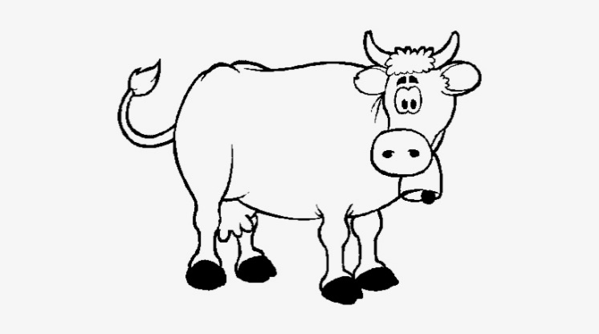
Using the template- you could colour each part of the body when you have the right number
Throw 6 colour the bell
Throw 5 colour body
Throw 4 colour a leg -only one at a time
Throw 3 colour the head
Throw 2 colour the udder
Throw 1 colour the tail

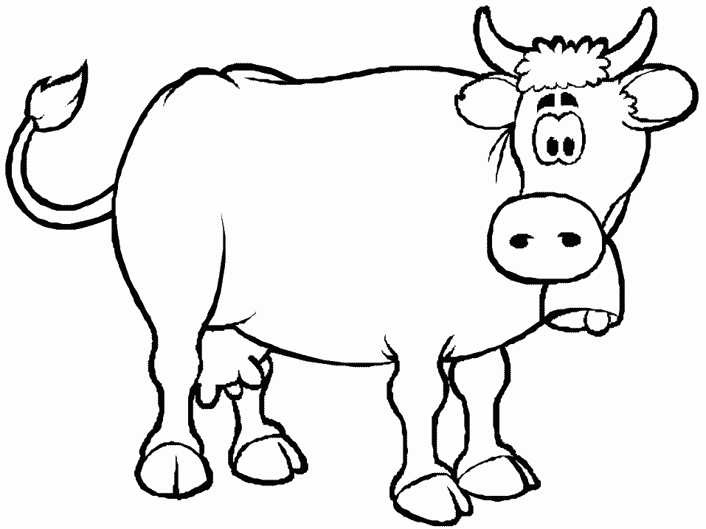
Template

Today’s theme is how God sometimes speaks through visions of strange things.

The Big Story – What’s in a Vision Genesis 37:1-10 and 40-41
You will need in the bag:
Face paint for dog face / dog mask
Cheese mask
Apron and towel (or large wine glass/goblet)
Bakers hat (or loaf of bread)
Four volunteers – dog, dog-walker, baker, cupbearer

Reader 1: Do you know what I’ve given up cheese.
Reader 2: Really but you are Mr/Mrs cheese, you eat, live and breathe cheese. I surprised you’re not called Mr/Mrs Gorgonzola.
Reader 1: Ok Ok, I’m not that bad.
Reader 2: Oh yeah turn out your pockets I bet you have some cheese on you right now.
(Reader 1 turns out his/her pockets and there is a baby bell cheese in there, and a dairy lea slice or some other little cheese)
Reader 2: You see you really are Mr/Mrs Cheese. So why are you giving it up.
Reader 1: Well it’s a bit weird really I keep having funny dreams and they say cheese makes you have funny dreams.
Reader 2: What? What kind of funny dreams?
Reader 1: Well one of them was about me and my dog...
Reader 2: Go on…
(Get some of the children to act out the dream, one can be the dog get a dog mask or draw a dog nose and tongue on them )
Reader 1: Well, I was walking the dog and the dog started to speak
Reader 2: What did it say?
Reader 1: he said to me “oh I don’t want to be walked any more I want to be carried” and jumped on my back!
(get child who is the dog to jump on the other persons back)
Reader 2: That’s a bit odd…
Reader 1: Oh you haven’t heard the half of it yet when he jumped on my back my face turned into a wedge of cheese.
(get cheese mask out of bag and put on dog walker)
Reader 2: Ok I think your right you really do need to lay off the cheese
Reader 1: I know that’s what I said, I bet nobody else has weird dreams like this!
Reader 2: Well actually there is a story in bible that is about dreams or to be more actuate they were visions because these had real meaning but they were as strange yours.
Reader 1: I don’t believe you.
Reader 2: Well there was a man named Joseph
Reader 1: Oh what he the one with the multi-coloured coat?
Reader 2: Yes, he was in a bit of a tricky spot.
Reader 1: Had he eaten too much cheese as well?
Reader 2: No he had been put in prison for something he didn’t do.
Reader 1: Well that’s not fair
Reader 2: Well no but he knew God had a plan for him because of a dream he had had years ago when he was still a boy living at home. He dreamt that the sun, the moon and lots of stars all bowed down to him!!
Reader 1: Did that make him big headed? Was he waiting for everyone to bow down to him?
Reader 2: Perhaps when he was younger – now he understood that it was God showing him something about his future, that God had a purpose for him even if he was in prison. Now two other people were in prison with him – who had both worked for the king of Egypt, the Pharaoh. One was the Baker and one was the Wine Waiter, or Cupbearer.
(get two children to be the butler and baker, putting a bakers hat on one and an apron and towel on the other, or give one a large loaf of bread and the other a large wineglass/goblet)
Now Joseph knew that some dreams were really visions from God. So when the Baker and the Cupbearer had a very weird dream they told Joseph all about it.
Reader 1: Was it about cheese?
Reader 2: No, The cupbearer said “In my dream there was a vine in front of me with three branches on it: It budded, blossomed, and the clusters ripened into grapes. I was holding Pharaoh’s cup; I took the grapes, squeezed them into Pharaoh’s cup, and gave the cup to Pharaoh.”
Reader 1: Wow that’s almost as weird as mine.
Reader 2: But Joseph knew what God was showing the Cupbearer. He said “Here’s the meaning. The three branches are three days. Within three days, Pharaoh will get you out of here and put you back to your old work—you’ll be giving Pharaoh his cup just as you used to do when you were his cupbearer. Don’t forget to tell Pharaoh about me and get me out of this place!”
[Cupbearer cheers and goes away happy]
Reader 1: Well that was good news, what about the baker?
Reader 2: Well the baker told Joseph “My dream went like this: I saw three wicker baskets on my head; the top basket was full of rolls from the bakery but birds were eating them.”
Reader 1: Oh that sounds lovely - I like a nice cheese roll
Reader 2: It wasn’t good news for the Baker. Joseph said “God is showing you: The three baskets are three days. Within three days Pharaoh will have you killed and no one will eat your baking anymore.”
Reader 1: Ergh that’s put me right off my cheese snack!
[Baker clutches throat and goes away unhappy]
Reader 2: And that’s just what happened to them both. But the Cupbearer forgot all about getting Joseph out of jail.
Reader 1: What after all he did for him?
Reader 2: Yes! But one day the Pharaoh himself had a vision which he was very worried about and asked who could help- and the Cupbearer told him about Joseph. So Joseph was brought to the Pharaoh. He told Joseph “He was standing by the Nile River. Seven cows came up out of the Nile, all shimmering with health, and grazed on the marsh grass. Then seven other cows, all skin and bones, came up out of the river after them and stood by them on the bank of the Nile. The skinny cows ate the seven healthy cows”
Reader 1: Woah he really needs to lay off the cheese!
Reader 2: Then he had another dream and this is how he described like this to Joseph “Seven ears of grain, full-bodied and lush, grew out of a single stalk. Then seven more ears grew up, but these were thin and dried out by the east wind. The thin ears swallowed up the full, healthy ears”
Reader 1: Wow I think I’ve lost my title as Mr/Mrs Cheese.
Reader 2: Well no these were visions sent by God. Joseph told the Pharaoh, God is letting you in on what is going to happen. Seven years of plenty are on their way throughout Egypt. But on their heels will come seven years of famine, leaving no trace of the Egyptian plenty. As the country is emptied by famine, there won’t be even a scrap left of the previous plenty—the famine will be total. Two dreams to show the same things because it is so important!
Reader 1: What he got all that from that dream - Joseph was amazing.
Reader 2: That’s what the Pharaoh thought too and put Joseph in charge of overseeing all of the preparations, storing up food for the time of famine and made him a very powerful man. Lots of people, including important leaders and even his own family, came to bow down before him and ask for help during the famine – and he was able to help feed them all.
Reader 1: Wow that’s a cool story.
Reader 2: God knew what he wanted Joseph to see and understand and Joseph trusted God to show him what the visions meant. I wonder what God wants us to understand and show us?

Creative adventure
God’s Eye: See demonstration and instructions here: https://www.thecrafttrain.com/basic-gods-eye-yarn-craft/
You will need:
- scissors
- multi-coloured yarn
- beads (optional)
- sticks of some sort (craft stick/lollypop sticks/chop sticks/twigs or small branches)
Instructions:
1. Hold your sticks in a cross shape (or star depending on the number of sticks you have) and wrap yarn around the centre until they are secure. You can tie the lose bits of string together or trim the once the craft is complete.
2. Wrap the yarn thread around one stick once, then move on to the stick next to it and wrap it around that. Keep on going by wrapping the yarn around each stick in the cross and moving on in a circular pattern.
3. Finish off your section by tucking the thread inside the last tight strand to stop it from unravelling.
4. Then simply start the pattern again with another colour of yarn until the time is up or your craft is complete.
Tips:
For small children you may find it helpful to glue the craft sticks together using ‘sticky glue dots.’
To keep the craft simple use only 2 sticks and 1 or 2 different coloured yarn.
To increase the complexity you can use up to 6 craft sticks, beads and a variety of different yarn colours to encourage experimentation with patterns.
One the ‘eyes’ are completed you can add thread so that they can be hung.
Wondering questions to use during creative time:
I wonder if you have ever had a vision from God?
I wonder how it might feel to receive a message from God?
I wonder how you would know that God had given you the vision?
The Adventure Map
Explain the Adventure Map and how a lot of the books were written hundreds and thousands of years before Jesus came to Earth. However, a lot of the stories in the Bible before the birth of Jesus, talk of his coming and set out how God wants us to live our lives.
Take the young people to the Adventure Map that you have created on the wall. Get the children to find where on the Map today’s story came from. Choose one or some of the things created by the children to be photographed and attach this to the wall to create a visual reminder of where the story came from and your adventure together. The aim is that in a year you will have lots of reminders of the stories and where in the Bible they come from. Use a piece of string or ribbon to connect the photo of the craft work to the book of the Bible.

Walking the Way
This is a time to invite the parents and carers back in to share what the children have been up to during the session. They will also be here to hear about the Walking the Way challenge and the tasks (should they choose to accept them) that the children (and parents) are about to undertake.
For the Younger: FOFA the bear
This is FOFA. FOFA likes nothing more than to go on an adventure; FOFA is a little more adventurous than me. FOFA believes that faith is a journey and that’s why FOFA would love to take you on a journey with him and walk the way of God in our everyday lives. Each session FOFA would like to go home with one of you and add to FOFA’s scrapbook of things you do together. FOFA doesn’t mind if you draw a picture of what you have done, take a photograph or just write a story about it. FOFA also doesn’t mind if you just come and tell the rest of us what you got up to together. But because FOFA’s memory isn’t very good as FOFA’s brains are made of stuffing, it would be better to save the memories in the book if you can. At the end of our time together we can always remember the great adventures we have been on together with FOFA and hopefully you will walk a little closer with God.

For the Older: FOFA cam
This camera is your window on the world. You have one shot at this, so choose carefully. You will be given a very precious piece of equipment – a FOFA cam. You have one photo to take with the camera, that records one thing – a way you have met the challenge. If there are other people in the photo, please ask their permission first and explain this photo will be put on display here. Bring back the camera and your photo next time to share your moment - and remember you only have ONE shot at this!
Every time we will choose someone to take FOFA bear and someone to take FOFA cam to help them with the challenge – but we can all have a go at the challenge!
Our Walking the Way Challenge this time is:
What is God showing you? What does God want you to know?
God tells us things through what we see in our imaginations and with our eyes!

Adventurers Go!
So, today we have heard about visions, and how sometimes when God wants us to understand things he shows us strange things to make us ask questions!
Prayers (choose one/both)
Joseph had a vision from God that helped him when life was difficult – it was a promise from God.
Thank you God for all the promises you make to love us and be with us.
Pharaoh had a vision from God that helped save lots of people from being hungry – it was a message from God.
Thank you God for all the messages from you we hear in the Bible stories we share.

Active Prayer
Stand or sit in a circle – turn to face outwards
Ask everyone to look around them – then ask WHAT DO YOU SEE? Use a talking stick/small item from the earlier story to pass around the circle and invite everyone to share what their eyes are drawn to (might be small thing/detail or an overview/large thing)
GOD IS INVITING YOU TO LOOK AT THIS – WHAT DOES GOD WANT TO SHOW YOU OR HELP YOU UNDERSTAND?
Use a talking stick/small item from the earlier story to pass around the circle and invite everyone to share what they think God is showing them (might be about them, about God, about the world etc)
(always good to model this by answering briefly yourself first each time)
Ask everyone to turn back to face the centre of the circle – and say together:
THANK YOU GOD FOR SHOWING US THINGS AND HELPING US UNDERSTAND MORE ABOUT YOU AND YOUR WORLD, AMEN.

End Prayer Every Session: All together
We are Friends on Faith Adventures, travelling together with God.
Adventurers go! Amen

What you need for this session
Fun Together
- Dice
- Colouring pens / pencils

Big Story
- Face paint for dog face / dog mask
- Cheese mask
- Apron and towel (or large wine glass/goblet)
- Bakers hat (or loaf of bread)
- Four volunteers – dog, dog-walker, baker, cupbearer

Creative adventure
- scissors
- multi-coloured yarn
- beads (optional)
- sticks of some sort (craft stick/lollypop sticks/chop sticks/twigs or small branches)

Location | Possible hazard | Action required | Action taken | Signature
During session | Use of make-up/face paint possible allergic reaction | Check for face paint/makeup intolerance with children | Check consent forms and ask participant if they are intolerant
During session | Use of sharpies and possible damage to clothes | Consider offering protective clothing | Offer children protective clothing and warn older children of the indelible nature of the pens.
During session | Use off scissors possible cutting of hands | Use rounded end scissors or closely supervise young children | Allocate a helper to the younger children or get an adult to do the cutting
During session | Blind folding children | Aware of anxiety and obstacles | Check if child is ok with blind folding and make sure that they are supervised at all times whilst blindfolded

