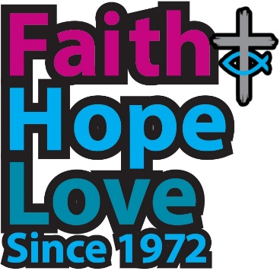
Together through the Father’s love

Winner of one of the hymn categories in the 50th anniversary Worship Resources Competition

Together through the Father’s love
we are one family.
His love in us, our love for him
holds all in unity.
Let us praise and sing
for he’s good and true;
love and mercy flows.
From him all things are made new.

Together on the Jesus road,
we learn his servant heart,
discovering that humility
is where true blessing starts.
Let us walk his way
raise our voice in song
to the Love, whose love
is our joy and makes us one.

Together when the Spirit leads,
her whisper like a dove,
resisting our complacency
she kindles gifts of love.
Let the breath of life
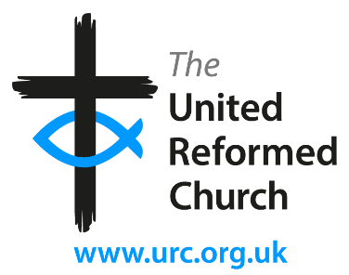
spark in us a flame
for a hurting world
to find comfort for its pain.

We stand together on this day
and make our pledge in faith,
with hope for all the future holds
and trusting in your grace.
We will journey on
guided by your Word;
voices, hearts and lives
singing “Jesus Christ is Lord!”
singing “Jesus Christ is Lord!”

Stephen Newell and Naomi Sharp

