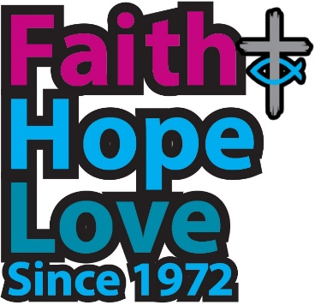
God of the Pilgrim Way

1 God of the pilgrim way,
guide of each generation,
through ever-changing years
our sure and firm foundation:
we turn to you, the source
of all that’s good and true,
the never-failing store
of treasures old and new.

2 We praise you for the lives
of those who went before us,
saints honoured, saints unsung,
the witness which they bore us;
for those who took to heart
the prayer of Christ the Son,
that all who bear his name
should be in Christ as one:

3 One Church, a house of peace,
where people long surrounded
by walls built to divide
meet, held in Love unbounded.
The suffering of our world,
the sorrows of our earth
cry for your healing touch,
long for a second birth.

4 And when the way grows hard,
and will and purpose fail us,
when dreams and visions die,
and doubts and fears assail us,
let wisdom from on high
our troubled spirits raise,
walk with us on the road
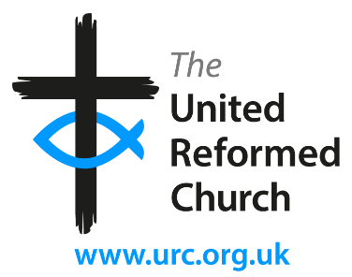
and set our hearts ablaze.

5 United for your sake,
by grace a new creation,
grant us the strength to serve
the work of your salvation:
hope for a world unsoiled
by terror, lies and greed,
faith in a future blest
where Love’s commandments lead.

Colin Thompson

Tune ‘Darmstadt’, Ahasuerus Fritsch (1629-1701)

Category: Traditional hymn; tune in the public domain.

Author’s note

This hymn is not so specific that it can only be used for anniversaries in the life of the URC, nor so general that it bears only a tangential relationship to the Jubilee.

It sets our own history during these fifty years in the broader context of the nature and mission of the whole Church, because the URC was never intended to be an end, only the beginning of a wider process of reuniting the separated parts of the one Church.

Nor is such greater reunion an end in itself, but the recalling of the Church to its mission as a living sign of healing and reconciliation in a fragmented world.

Within that context, our particular history is recalled in the second verse, with its thanksgiving for those who prepared the way for the 1972 Union, while our own identity and purpose is present at the beginning of the final verse: ‘United’, and ‘a new creation’, which is another, biblical way of saying Reformed.

Biblical references:
v1 Psalm 90, James 1.17-18, Matthew 13.52
v2 Hebrews 12.1, John 17.20-21
v3 Ephesians 2.14, Romans 8.22, Matthew 9.20-21
(and other miracles of touching), John 3.5
v4 I Samuel 3.1, James 3.17, Luke 24.13-32
v5 2 Corinthians 5.17, Philippians 2.12, 1 Corinthians 13, Matthew 22.37-40, John 13.34

These words were written for the tune ‘Darmstadt’, by Ahasuerus Fritsch (1629-1701). To my mind it is one of the noblest chorales of the Lutheran Reformation, especially as set by Bach (copy below). I have chosen it because it is both old and (to us) new. The hymn could also be sung to ‘Nun danket’ (Rejoice and Sing, 72), but for the reason just given, that would rather defeat the purpose.

