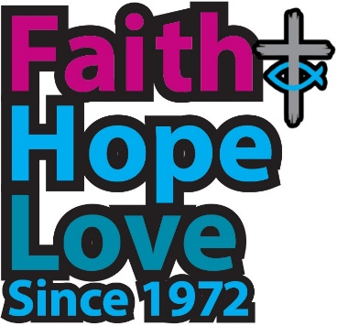
Always trust the star
that guides you

Winner of the Poetry Category in the 50th anniversary Worship Resources Competition

“Let them be, as we are; one,” we hear you say.
Those treasured roots do not have to cling so tight.
Always trust the star that guides us on the way.

In this aching world your dreams can be the prey:
Ignored; forgotten; fading out of sight.
“Let them be, as we are; one,” we hear you say.

Set sail. Become an answer to what you pray.
Risk open ocean where storms can reach their height.
Always trust the star that guides us on our way.

Sail on. Discern all the Spirit has in play,
Set course by sacrament and word. Know what’s right.
“Let them be, as we are; one,” we hear you say.

Defensiveness, fear, might seem to rule the day,
This is why our love, hope, faith must shine so bright.
Always trust the star that guides us on the way.

Fifty years; our life always yours, come what may,
Pilgrim servants sailing still. Travelling light.
“Let them be, as we are; one,” we hear you say.
Always trust the star that guides us on the way.

The Revd Neil Thorogood

