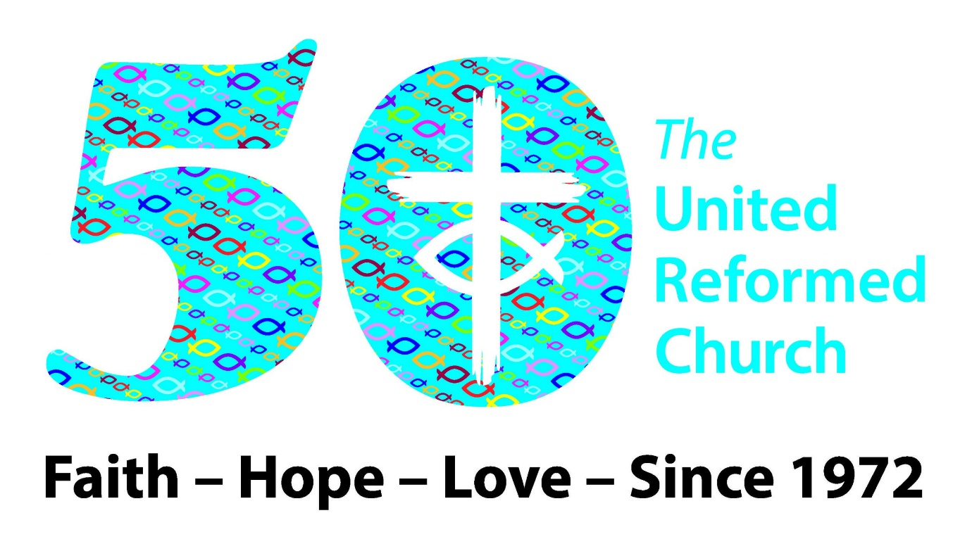

COMMEMORATE, CELEBRATE, CREATE!

INTRODUCTION:

This resource is designed for youth groups to access and use, rough timings have been added next to each section amounting to 90 minutes overall but plan your activities around how much time you have within your session. You may choose to do all activities or to just chose the ones which are most suitable for your group and the time you have. Alternatively, you could carry these activities over 2 sessions or more.

What you will need:
- A box of celebrations
- Seed paper – one per person
- 1972 event game – one per person (Appendices 1)
- Bingo sheet 9 square grid – one per person (appendices 2)
- Large Bingo sheet examples to select from – two (appendices 3)
- Pens
- Paper

Follow link for more resources connected to the URC’s 50th Jubilee:
https://urc.org.uk/who-we-are/our-50th-anniversary/

AIM OF THE RESOURCE: To explore what has happened in the past that has shaped our present, to think about how we can help to shape the future; celebrate difference and diversity and invite everyone to share the good news of Jesus.

Opening Prayer

Ask if anyone in your group would like to say a prayer for the beginning of the session, if not feel free to use this one or make up your own.

Dear God,
Thank you for giving us the opportunity to gather here today. Thank you for protecting us as we travelled to be here and for providing the way for us to meet, learn, and grow. Clear our minds of all other things so that we can dedicate this time to you.
Your Word says in Colossians 3:17, “And whatever you do, whether in word or deed, do it all in the name of the Lord Jesus, giving thanks to God the Father through him.” Thank you for blessing our time together. Help us make new connections and gain wisdom to do the work you’ve set before us. We give you honour and glory, Lord.
In Jesus’ name we pray,
Amen.

An ice breaker activity to help introduce each other/ new members or to get to know each other better.

Activity 1 - Speed Dating Icebreaker (10 mins max)

Get everyone to stand up and find a partner. Read out the first question, give a minute to answer. Then make everyone move and find a different partner – read out the next question – continue until all questions are answered or your time is up.
Feel free to add your own questions!

Favourite pizza topping?
If you could be an animal what animal would be?
Favourite cartoon/Disney character?
If you were a kitchen implement, what would you be?
Favourite tv show as a child?
Favourite snack?
Favourite holiday/place you’ve been to?
3 people you’d invite to a dinner party, one alive, one dead, one fictional
Place you must visit / thing you must do before you die?

Activity 2: Dragon’s Den to change the world (20 mins)

This activity gives the young people an opportunity to share their passions for the world, it can help nurture skills of communication and can demonstrate how in the URC young people are encouraged to share their ideas with their church, synod or at URC Youth Assembly. This is how URC Youth finds its collective voice on the things that matter to them.

Explain everyone needs to pitch their suggestion for what they would do if they were given £1,000 to change the world.
The group will then decide which is the best suggestion!

First give everyone 5 minutes to prepare their one-minute pitch:
How would you use £1000 to change the world?

Then in 3s each shares their idea in 1 minute – and they have to agree on the best one to go forward to next round (5 mins)

Then round winners all pitch their ideas to the whole group and the group agrees the winner (5 mins)

(Optional/ if appropriate: consider researching whether there are any grants available in your local area for the group to apply for using the winner’s suggestion)

Activity 3: 1972 landmark events (10 mins)

Get your group to read through the list of events from 1972 (APPENDICES 1) (50 years ago – the year the URC was founded). Invite everyone to vote for their top three which they think are the standout events that should be commemorated (use the first blank column – write 1st, 2nd and 3rd by your choices).
With a partner share why and what wider stories these events are part of today.

These are the events:

- Jan 14 Margrethe II of Denmark becomes the first Queen of Denmark since 1412
- Feb 5 Bob Douglas is 1st African American elected to Basketball Hall of Fame
- Feb 17 British Parliament votes to join the European Common Market
- Mar 25 17th Eurovision Song Contest: Vicky Leandros for Luxembourg wins singing "Apres toi" in Edinburgh
- Jul 1 The first Gay Pride march in England takes place.
- Jul 7 Wimbledon Women's Tennis: Billie Jean King earns her 8th Grand Slam singles title beating Evonne Goolagong of Australia 6-3, 6-3
- Sep 1 American chess grandmaster Bobby Fischer beats Russian champion Boris Spassky 12.5-8.5 in Reykjavik, Iceland; most publicised world title match ever played; Fischer 1st American to win title
- Sept 5-6 Summer Olympic Games in Munich, Germany suspended due to Black September massacre (terrorist attack)
- Oct 26 Guided tours of the former prison at Alcatraz by the National Park Service begin
- Nov 7 Attorney Joe Biden is elected to the US Senate, representing the state of Delaware after defeating long-time incumbent J.Caleb Boggs by just over 3,000 votes; Biden would win re-election 6 times
- Dec 7 Apollo 17 launched, the final manned lunar landing mission where the crew takes the famous "blue marble" photo of the entire Earth

Activity 4: Bible passage linked discussion (10 mins)

Read Joshua 4:1-7 together and discuss what landmarks or memorials have been erected in people’s churches and communities – what do these commemorate? What have they been told / would they want to tell the next generation about these people or events? How can they be part of shaping the stories for the future? Does the past need to be reinterpreted?

Joshua 4:1-7 New Revised Standard Version, Anglicised

Twelve Stones Set Up at Gilgal
4 When the entire nation had finished crossing over the Jordan, the Lord said to Joshua: ² ‘Select twelve men from the people, one from each tribe, ³ and command them, “Take twelve stones from here out of the middle of the Jordan, from the place where the priests’ feet stood, carry them over with you, and lay them down in the place where you camp tonight.”’ ⁴ Then Joshua summoned the twelve men from the Israelites, whom he had appointed, one from each tribe. ⁵ Joshua said to them, ‘Pass on before the ark of the Lord your God into the middle of the Jordan, and each of you take up a stone on his shoulder, one for each of the tribes of the Israelites, ⁶ so that this may be a sign among you. When your children ask in time to come, “What do those stones mean to you?” ⁷ then you shall tell them that the waters of the Jordan were cut off in front of the ark of the covenant of the Lord. When it crossed over the Jordan, the waters of the Jordan were cut off. So these stones shall be to the Israelites a memorial for ever.’

Activity 5: Play diversity bingo (10 mins)

Each person needs a grid and a pen. (APPENDICES 2) Put the large, filled grid (APPENDICES 3) (2 copies) where everyone can see it. Each person has to pick 8 things from the grid and add one of their own devising and filling out their own bingo grid with these (3 mins) – how diverse do you think this group is?
They then need to go around the group and find someone who matches each item on their grid – the person needs to sign their name on the sheet. The first person who finishes is the winner (and will get the Celebrations chocolates – but they can’t eat them yet as they are needed for the prayer).
Please keep the sheets, if possible, they will be reused.

This activity is about celebrating the diversity in the group, not pointing out differences that might make people uncomfortable.

Activity 6: Bible passage linked discussion (10 mins)

Read Luke 4:16-21 together and discuss what this passage says about celebrating everyone, including everyone, and diversity. The passage is titled ‘The rejection of Jesus at Nazareth’ – what do you think people found unacceptable about Jesus that made them want to throw him out of their community? Some people see this passage as the Gospel Manifesto – the good news – what would you want to celebrate as good news?

Luke 4:16-21 New Revised Standard Version, Anglicised

The Rejection of Jesus at Nazareth
¹⁶ When he came to Nazareth, where he had been brought up, he went to the synagogue on the sabbath day, as was his custom. He stood up to read, ¹⁷ and the scroll of the prophet Isaiah was given to him. He unrolled the scroll and found the place where it was written:
¹⁸ ‘The Spirit of the Lord is upon me,
because he has anointed me
to bring good news to the poor.
He has sent me to proclaim release to the captives
and recovery of sight to the blind,
to let the oppressed go free,
¹⁹ to proclaim the year of the Lord’s favour.’
²⁰ And he rolled up the scroll, gave it back to the attendant, and sat down. The eyes of all in the synagogue were fixed on him. ²¹ Then he began to say to them, ‘Today this scripture has been fulfilled in your hearing.’
Activity 7 – Origami (10 mins max)

Create something out of paper, paper aeroplanes or fortune tellers work well, if you don’t know how to make these ask in your group, any other ideas from your group should be encouraged. Someone may be an origami expert!

Whilst creating and if some people prefer not to make something, have a conversation about how to create a better future, within the church or the environment

Activity 8 – Seed paper – grow your own goals (10 mins max)

Read Matthew 5:13-16 together:

Matthew 5:13-16 The Message

Salt and Light
¹³ “Let me tell you why you are here. You’re here to be salt-seasoning that brings out the God-flavours of this earth. If you lose your saltiness, how will people taste godliness? You’ve lost your usefulness and will end up in the garbage.
¹⁴⁻¹⁶ “Here’s another way to put it: You’re here to be light, bringing out the God-colours in the world. God is not a secret to be kept. We’re going public with this, as public as a city on a

hill. If I make you light bearers, you don’t think I’m going to hide you under a bucket, do you? I’m putting you on a light stand. Now that I’ve put you there on a hilltop, on a light stand—shine! Keep open house; be generous with your lives. By opening up to others, you’ll prompt people to open up with God, this generous Father in heaven.
Give everyone a piece of seed paper and a pen. Invite them to spend 5 mins talking with a partner about what they could personally do to create a better future for themselves, their community, the church or the environment. You might like to give some examples:
I could create a better future for myself by recycling more
If I walk more, then I would be creating a healthier planet
I want to talk to my minister to create a more open environment for young people

Get your group to write down on their seed paper an achievable goal and a goal that will take some effort and commitment on their part. Tell them that they can take this home and plant it (instructions?) and watch the plants grow as they try to create this better future.
Invite people to share their goals if they would like to.
Invite everyone to pray over their seed paper, asking God to help them be co-creators of a better world for all.

Prayer 1 (choose one or if time use both)

Celebration’s chocolates needed – ask the Diversity Bingo winner to give away to other people in the group the chocolates mentioned as you read the prayer:

God, we thank you that we are all able to celebrate here together, we celebrate your bountiful creations throughout the galaxy. We thank you for always showing us the (milky)way no matter if we end up as far away as mars, thank you that you never malteaser and snicker at us. Betwixed and between our first and last breath you are always with us and that your love is as good to us as the rich sweetness of caramel.

Prayer 2

Creator God, we see around us the wonderful creations that you have made, the people in this room and the life outside it, guide us in creating our futures and helping us to make them better with your love. Help us to create church that are open to all, and a world that is full of peace, help us to find ways to create a future that always has room for you no matter how busy we find ourselves. We ask this in your name. Amen

APPENDICES 1
1972 EVENTS select your top 3 standout events

- 14th January | Margrethe II of Denmark becomes the first Queen of Denmark since 1412
- 5th February | Bob Douglas is 1st African American elected to Basketball Hall of Fame
- 17th February | British Parliament votes to join the European Common Market
- 25th March | 17th Eurovision Song Contest: Vicky Leandros for Luxembourg wins singing "Apres toi" in Edinburgh
- 1st July | The first Gay Pride march in England takes place.
- 7th July | Wimbledon Women's Tennis: Billie Jean King earns her 8th Grand Slam singles title beating Evonne Goolagong of Australia 6-3, 6-3
- 1st September | American chess grandmaster Bobby Fischer beats Russian champion Boris Spassky 12.5-8.5 in Reykjavik, Iceland; most publicised world title match ever played; Fischer 1st American to win title
- 5-6th September | Summer Olympic Games in Munich, Germany suspended due to Black September massacre (terrorist attack)
- 26th October | Guided tours of the former prison at Alcatraz by the National Park Service begin
- 7th November | Attorney Joe Biden is elected to the US Senate, representing the state of Delaware after defeating long-time incumbent J.Caleb Boggs by just over 3,000 votes; Biden would win re-election 6 times
- 7th December | Apollo 17 launched, the final manned lunar landing mission where the crew takes the famous "blue marble" photo of the entire Earth
Put 1, 2 and 3 in the box by your first, second and third choice

APPENDICES 2
Bingo sheet

How diverse do you think this group is?

Fill in the boxes with 8 suggestions from the large sheet and one of your own.

Then for each box find someone in the group about whom this is TRUE - get them to sign the box.

First person to have all 9 boxes signed by different people shout BINGO and wins!

I can speak another language | I can play a musical instrument | I can wiggle my ears or nose
I have dyed my hair | I have a tattoo | I wear a cross
I love marmite | I hate marmite | I am a vegetarian
I have won something | I have been on TV | I have met someone famous
My favourite colour is blue | My favourite colour is purple | I have a pet
I am in a sports team | I sing in the shower | I have a houseplant
APPENDICES 3

