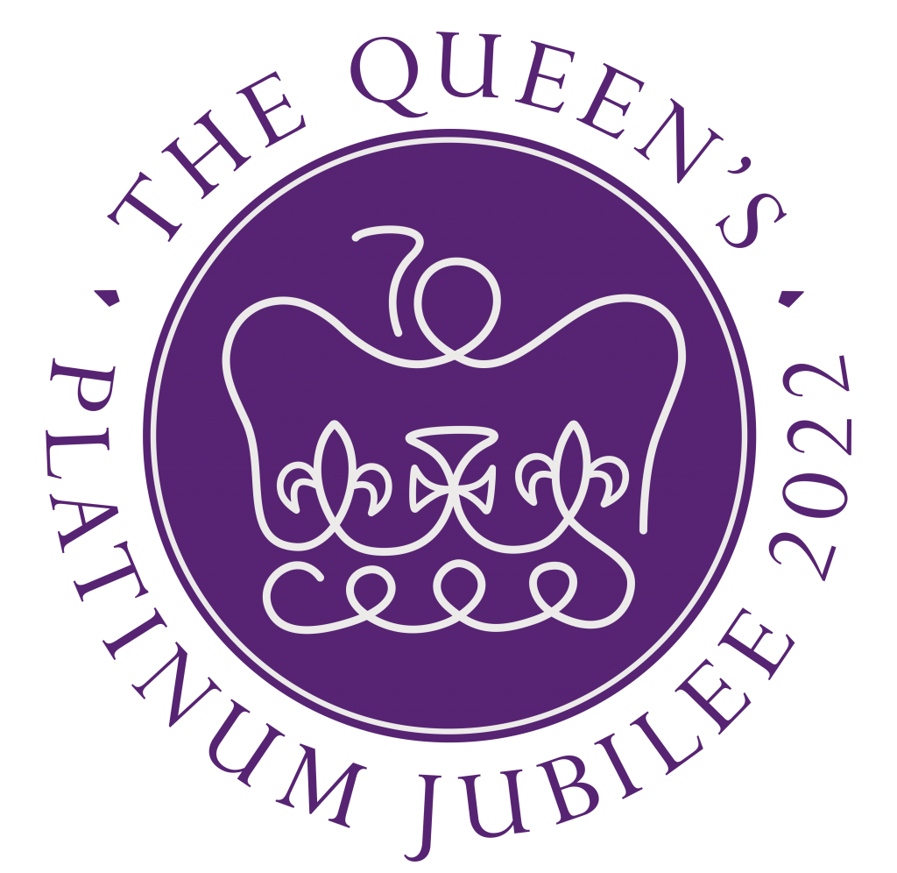
The Queen’s Platinum Jubilee

A service marking the 70th anniversary of the reign of Her Majesty The Queen from the United Reformed Church

This Order of Service was commissioned by the URC’s Worship Reference Group. Please include all acknowledgements however and whenever you use this resource. Please use all of it or parts of it as fits your needs.

Preparation notes

- Dates – The official Platinum Jubilee Celebrations will occur 2-5 June 2022. This service may be used any time.

- Children’s activities – Suggestions are included in this document.

- Jubilee medallists – If there are local recipients of the Platinum Jubilee medal, consider including a time in the service to recognise these recipients, people who work in public service including representatives of the Armed Forces, the emergency services and the prison services. The tradition of a Jubilee medal stretches back to the reign of Queen Victoria when an official medal was designed to mark her 50th anniversary on the throne.

- Songs – We celebrate the URC’s current hymn writers by offering new hymns in this service. You may wish to use fewer, or different, hymns. Suggestions for an anthem appears at the end of this document.

- Acknowledgements – Please include acknowledgements in printed service sheets and on audio visual presentations.

- Flowers – Consider creating an arrangement using the flowers from the 1953 coronation bouquet -- a floral symbol of the United Kingdom: England - orchids and lilies of the valley; Scotland – stephanotis; Wales – orchids.
You might add the national flower of Northern Ireland – shamrocks, and the unofficial national flower of the Isle of Man - ragwort (also known as cushag).

Order of Service

Gathering

We gather for this service to worship and praise God giving thanks as we mark the Platinum Jubilee of The Queen’s reign. We celebrate seventy years of her sovereignty and service. Whatever our feelings toward the monarchy and nobility, we can all look to Queen Elizabeth with respect and gratitude for her life of faithful service.

[optional]
When asked if she would like to suggest an item for inclusion in the service, the following written response was received from Balmoral Castle:

‘The Queen has been deeply moved by the loyalty and support she has received throughout her long reign from her subjects both at home and within the Commonwealth, and the sentiments you express as you prepare a Service of Thanksgiving to celebrate her Platinum Jubilee … are greatly appreciated. It was kind of you to make Her Majesty aware of your considerate suggestions for this Service and the Queen greatly appreciated your kind thoughts.’ Signed: Annabel Whitehead, Lady-in-Waiting.

This special service highlights hymns, prayers and psalms written by members of the United Reformed Church in Great Britain, celebrating our church’s diversity and witness throughout this realm.

Reading from the Psalms

Our first reading arises from Psalm 98, written by Revd Carla Grosch-Miller.

Sing aloud for joy!
Conjure magnificent melodies!
Create meteoritic metaphors!
Reach for the heights of beauty
and the depths of drama!
Use everything to hand --
all that you can make
and all that you can imagine:
stardust and earthdreams,
the music of the spheres
and the murmur of silence,
the hunger of the heart
and the hope everlasting.

The Power within and beyond,
the Presence throughout,
the Wonder and the Glory
call for nothing less
than the full expression
of all that we are
and all that we have.

There is no place
on earth or in the heavens
that has not been soaked in,
tickled or teased by Divine Love.

There is no living creature
on earth or in the heavens
that has not been marked,
grazed or embraced by the Divine Kiss.

There is no song
too lowly or too grand
to offer in praise
and thanksgiving.

Bring your instruments:
blow your horns,
strum your strings,
pound your pianos,
lift Your voices.

Match the roar of the oceans
and the majesty of the mountains.
Let all things magnify Holy might.
Let all things reflect Holy light.

Nothing is apart from,
and all is a part of,
God
whose immensity,
mercy and justice
are forever.

Opening Hymn

Creator God, your love abounds, lyrics by Revd Ana Gobledale
Tune: Oh Lord, my God (How Great Thou Art)

Creator God, your love abounds forever;
Creation’s beauty fills the earth and sky.
Your shining stars, the universe expanding,
Amazing power, creation does display.

Chorus: Creator God, we lift our song to you,
How great your love, how great your love. (repeat)

When through the fields, and mossy woods we wander,
we hear the birds, and rustling of the leaves;
When we absorb the sunrays shining brightly,
And feel the shade beneath the spreading trees, Chorus
Walking the streets, through city ways and byways
We hear the sounds of life and children’s play;
When justice rings from every church’s spire
We feel the hope of promises you’ve made. Chorus

And when we think, how love and peace surround us,
Eternal One, we scarce can take it in,
Your truth, your realm, your justice spreading broadly,
Our hearts are filled, for Love has entered in. Chorus

Prayer of Praise & Thanksgiving

Join me in prayer.
Gracious God, how great your love!
We lift our song to you as we gather with praise and thanksgiving on our hearts. We come, part of the rainbow of your family, from the nations of this United Kingdom and the Commonwealth, rich in our diversity and culture.
We come as people of faith to give you thanks for Her Majesty The Queen -- a leader, a mother, a wife, a servant.
Thank you for her life of service and the example of her deep sense of vocation.
May she continue to be blessed with divine guidance and find strength in her faith.
May she be encouraged by the widespread celebration of this Jubilee.
May we who gather today be enriched and strengthened by today’s service.
May the words, spoken and sung, lift our spirits that we might leave this place steadfast in our role as your ambassadors and Christ’s disciples. Amen.

Reading from the Prophets Micah 6.6-8

Our reading from the Old Testament is from the Prophet Micah who writes:
‘What shall I bring when I come before God,
and bow down before God on high?’ you ask.
‘Am I to come before God with burnt offerings? With year-old calves?
Will God be placated by thousands of rams, or ten thousand rivers of oil?
Should I offer my firstborn for my wrongdoings--
the fruit of my body for the sin of my soul?’
Listen here, mortal,
God has already made abundantly clear what ‘good’ is,
and what God needs from you:
simply do justice, love kindness, and humbly walk with your God.

Prayer of Confession

As we prepare to confess our sins, may we be enlightened by the words of Queen Elizabeth, from her 1984 Christmas message.
‘Above all, we must retain the child’s readiness to forgive, with which we are all born and which it is all too easy to lose as we grow older. Without it, divisions between families, communities and nations remain unbridgeable. We owe it to our children and grandchildren to live up to the standards of behaviour and tolerance which we are so eager to teach them…. We should work to heal old wounds and to abandon prejudice and suspicion.’

‘Forgiveness lies at the heart of the Christian faith. It can heal broken families; it can restore friendships and it can reconcile divided communities. It is in forgiveness that we feel the power of God’s love.’

Join me in prayer.
Merciful God, we approach you asking for forgiveness,
For healing and reconciliation
To once again feel the power of your Love.
As individuals and as a nation we have tempted fate.
We have not simply done justice and loved kindness.
We have stretched our grasp with greed.
We have protected our privacy with isolationism.
We have ravaged your creation with entitlement.
Forgive us.
As we are forgiven, may we,
with the readiness of a child, forgive others.
Those who have caused division and pain
Those who spread intolerance and prejudice
Those who destroy that which we try to build up.
Open our hearts to abandon prejudice and suspicion.
As we teach our children tolerance, may we be tolerant.
Use us to restore harmony
That all may humbly walk with you
And feel the power of your love.
This we pray in the name of the great healer, Jesus. Amen

The Lord’s Prayer

We now join our voices together saying The Lord’s Prayer interpreted for today, by Mary Carpenter.
Loving God, we know that you forgive us our trespasses as we must forgive those who trespass against us.
And yet how hard we find it to follow your loving example in our day to day lives.
Help us to resist the temptations of revenge and retribution and turn instead to the loving kindness of forgiveness and reconciliation.
Help us to forgive others for their shortcomings.
Help us also to forgive ourselves for our own shortcomings, for which we know you have already forgiven us.
Loving God, when we are brought low, you help us.
You save our eyes from tears and you keep our feet from falling.
You are ever-pardoning and ever-forgiving.
Let us reflect your love in our treatment of others, and let us work for justice, reconciliation and forgiveness throughout your peoples.

Assurance of grace Psalm 85 Renewed, by Revd Duncan Wilson

God of all, how kind you are to your people,
for you forgive our sins
and are gentle with our shortcomings.
You hold back your displeasure
and your anger never lasts for long.
It is what we need, this ever-present love
and your saving hand when trouble comes.
We are listening to what you say,
especially your promise that peace will come
when we turn from our foolish ways
Then Love and Loyalty will hold hands,
Justice and Peace will embrace.
Even as we turn to find you,
we find assurance knowing that
you are looking upon us now.

Hymn

Let me walk in love beside you, lyrics by the Revd Ray Stanyon
Tune: St Andrews

Let us walk in love beside you
All along life’s dusty road
Hearing, knowing every burden
Let us help to share your load

Wounds and pain arise to rob us
Of a love community
Guard us from a self-importance
Seeing you as less than ‘we’

Let us rise and risk for justice
Walk a mile within your shoes
Striving for a world that’s far too
Precious in God’s eyes to lose

Whether sitting or if active
May we always do what’s best
God the focus of attention
God our source, our work, our rest

The Litany of Prayer and Thanksgiving (include young people as readers, when possible) Adapted from the 2012 Jubilee service

Today we celebrate the life and service of Her Majesty Queen Elizabeth. Join me in a responsive litany of thanksgiving. When I say ‘God over all,’ please respond saying ‘we give you thanks’. Pray with me.

God over all, we give you thanks.
God our source, our work our rest,
We give thanks for nations and leaders around the world.
God over all, we give you thanks.
We give thanks for Her Majesty's reign of seventy years and the example of a life symbolised by duty and sustained by faith.
God over all, we give you thanks.
We give thanks for the members of the Royal Family who have given service to this country and its people.
God over all, we give you thanks.
We give thanks for all the citizens of this realm.
God over all, we give you thanks.
We give thanks for the practices and values of these lands,
God over all, we give you thanks.
We give thanks for governance that cares for both citizens and global neighbours.
God over all, we give you thanks.
We give thanks for the steadfast witness of the Christian Church and of communities of faith here and around the world.
God over all, we give you thanks.
We give thanks that we can gather in our diversity and celebrate today.
God over all, we give you thanks. Amen.

Prayer for the Queen

Let us continue in prayer.
God of Creation
Designer of sameness and diversity,
of time and eternity,
we give you thanks and praise.
Today we especially pray for Queen Elizabeth.
In this year of Jubilee, grant her your gifts of love, joy and peace
as she continues in faithful obedience to you, her God,
and in devoted service to the people of these islands,
and those of the Commonwealth.
Illuminate her path that she may walk in your way,
now and all the days of her life.
This we pray in the name of Jesus. Amen.

Children’s Message

To love mercy – the sword with the broken tip
Preparation: Collect these articles in a soft bag:
- Contemporary photo of Queen Elizabeth
- Photo of coronation
- Picture of the broken-tipped Sword of Mercy

Script:
I have something in my bag.
[Take out a recent photo of Queen Elizabeth]
Who is this? [Queen Elizabeth]
Yes. Today we are thinking about Queen Elizabeth. Who can tell me how many years she has been the Queen? [70]
Yes. That’s a long time, 70 years.
What year was it 70 years ago when she became queen? [1952].
[Take out a photo of the young Elizabeth at her Coronation.]
Who do you think this is?
Yes. This is Queen Elizabeth on the day in 1952 when she became Queen.
There was a special service, a coronation, held that day.
At that service there were several symbols given to the new queen.

Each symbol is to help her remember something important.

[Remove from bag: a picture of a sword with a broken tip.]
What’s this? [a sword]
Yes. One of the symbols given to the new Queen is a sword.
But it’s not like most swords.
Can you see something different about this sword?
Look at the tip? Is it sharp and pointed?
No. This sword, given to the new queen, actually has a broken tip. It was broken on purpose, to remind her of something. Why do you think the tip is broken? A broken sword might remind the Queen of…what?
[Let the children share their ideas.]
This sword with its broken tip symbolises mercy. In fact, it has a special name: Curtana, The Sword of Mercy. The broken tip reminds the Queen that she must not be cruel, but be merciful. She must find ways to bring peace not hardship in her judgements. Just like the prophet Micah said, as we heard read, ‘What does God require of you? To act justly and to love mercy and to walk humbly with your God.’

Pray with me.
God of mercy, thank you for reminding the Queen and us that we should not be cruel or hurtful, but rather be merciful, acting with justice and kindness. Amen.

Hymn Bring us your Peace by Sam Goodman
Tune: Lobe den Herren ‘Praise to the Lord’

Bring us your peace
Wrap us gently in love that can calm us
Save us from fear
And protect us from hurts that can harm us
And as you heal
Show us your mercy is real
Live in our hearts and refresh us

Bring us your hope
Let us trust how you comfort and guide us
Let us give thanks
For the gifts that you daily provide us
All we receive
Gives us the strength that we need
Live in our lives and refresh us

Bring us your truth
Let it conquer the lies that dismay us
Shape and remould us
Enfold us in love as you save us
Teach us to be
Touched by your mercy set free
Live in our homes and refresh us

Bring us your light
Show us darkness can never defeat it
Show us your vision
And how we can serve to complete it
Let your light shine
Let it be your will, not mine
Live in our love and refresh us

The New Testament Reading Romans 12. 1-18 NRSV

Today’s reading from the New Testament is taken from Paul’s letter to the people of Rome, a reading that was also read at the 2012 Royal Jubilee service. Paul writes:

‘I appeal to you therefore, sisters and brothers, by the mercies of God, to present your bodies as a living sacrifice, holy and acceptable to God, which is your spiritual worship. Do not be conformed to this world, but be transformed by the renewing of your minds, so that you may discern what is the will of God—what is good and acceptable and perfect.

‘For by the grace given to me I say to everyone among you not to think of yourself more highly than you ought to think, but to think with sober judgement, each according to the measure of faith that God has assigned. For as in one body we have many members, and not all the members have the same function, so we, who are many, are one body in Christ, and individually we are members one of another. We have gifts that differ according to the grace given to us: prophecy, in proportion to faith; ministry, in ministering; the teacher, in teaching; the exhorter, in exhortation; the giver, in generosity; the leader, in diligence; the compassionate, in cheerfulness.

‘Let love be genuine; hate what is evil, hold fast to what is good; love one another with mutual affection; outdo one another in showing honour. Do not lag in zeal, be ardent in spirit, serve the Lord. Rejoice in hope, be patient in suffering, persevere in prayer. Contribute to the needs of the saints; extend hospitality to strangers.

‘Bless those who persecute you; bless and do not curse them. Rejoice with those who rejoice, weep with those who weep. Live in harmony with one another; do not be haughty, but associate with the lowly; do not claim to be wiser than you are. Do not repay anyone evil for evil, but take thought for what is noble in the sight of all. If it is possible, so far as it depends on you, live peaceably with all.’
Here ends the reading. May God bless us with understanding.

Hymn We find ourselves between two worlds by Stephen Best
Tune: Gonfalon Royal

We find ourselves between two worlds,
In one we live, for one we hope
To risk their fusion is our call,
Achieved through love, which welcomes all.

Achieved through love, which welcomes all,
Which bends and breaks and mends again,
The source of all; and yet it serves;
Eternal friend, divine, at one.

Eternal friend, divine, at one
With us; within, around, beyond.
Love calls us on, we plant its seeds
In hope that this same love will grow.

In hope that this same love will grow,
We bend and break and mend again
Because the goal is worth the pain
We find ourselves between two worlds.

The Sermon - to be prepared locally

Quotations from Queen Elizabeth for reflection

‘I know just how much I rely on my faith to guide me through the good times and the bad. Each day is a new beginning. I know that the only way to live my life is to try to do what is right, to take the long view, to give of my best in all that the day brings, and to put my trust in God…I draw strength from the message of hope in the Christian gospel.’ -- Queen Elizabeth, 2002 (p.6 in The Servant Queen, by Mark Greene & Catherine Butcher)

‘Love your Neighbour’
The Queen, in her 1975 Christmas message said, ‘His [Jesus’s] simple message of love has been turning the world upside down ever since. He showed that what people are and what they do, does matter and does make all the difference…. It does matter therefore what each individual does each day. Kindness, sympathy, resolution and courteous behaviour are infectious. Acts of courage and self-sacrifice …are an inspiration to others. And the combined effect can be enormous…. We may feel powerless alone but the joining efforts of individuals can defeat the evils of our time. Together they can create a stable, free and considerate society.’ (p.49 in The Servant Queen, by Mark Greene & Catherine Butcher)

Prayers for our World Kairos! by Karen Campbell

Join me in prayer written by Karen Campbell, Secretary for Global & Intercultural Ministries for the United Reformed Church.

God, in whose likeness all are made,
teach us to see each other
as you see us –
each individual,
nation and people -
beautiful.
Beloved.
Valued beyond measure.
Enable us
to see as you see.

God, who is love,
teach us to love each other
as you love us -
from the very heart
of who we are,
embracing friend,
embracing neighbour,
embracing stranger.
Generous,
self-giving,
surmounting all barriers –
real and perceived.
Move us
to love as you love.

God, who is impartial,
teach us to strive
as you strive -
raging with the oppressed,
unsettling the comfortable,
refusing to be stilled
or quieted
until your cries for justice
are heard,
and echoed,
and lived into being.
Stir us to be agents
of challenge
and change.

God of justice,
God, who demands justice,
move us from the inactive, safe, silent,
place on the fence.
Open our eyes – now.
Move us to listen – now.
Make us hear – now.
Speak out – now.
Speak up – now.
Struggle and move and act for justice -
right now -
in our world,
our nation,
our Church - today.
Amen.

Offertory
Invitation:
Queen Elizabeth speaks of sacrifice and courage. May her words be an inspiration to us that we, in our sacrificial giving, may be an inspiration to others.

Today’s collection will go to support the work of this local church and (a named charity).

Prayer of Dedication:
Pray with me. Gracious God, receive these gifts that represent our love for you and our commitment to act for justice. May they reflect the self-sacrifice described by Queen Elizabeth and be used boldly as we join efforts to ‘defeat the evils of our time.’ Amen.

Hymn Love alone by Revd Stephen Best
Tune: Blaenwern

Any words which we may utter,
Without love to reach their goal,
Are no more than clashing cymbals,
Empty gongs without a soul.
Though we conjure future visions,
Understand life’s wherewithal,
And have faith which moves the mountains,
Without love we are not whole.

Acts of charitable giving
And the self-denial call,
If such actions have no loving,
we gain nothing from them all.
Love is patient, love is kindness,
Knows no envy does not boast,
Bends itself to others’ pathways,
Hopes, believes and endures all.

Everything has its own season,
Children once, we now stand tall.
In adulthood still our vision
Through dark mirrors captures all.
While we search for understanding,
Faith and hope and love still call,
And in future generations,
Love alone will outlive all.

Commissioning

In 1939, words taken from a poem by Minnie Louise Haskins were shared by Princess Elizabeth, then 13 years old, with her father. According to one biographer, Elizabeth told her father that she, ‘thought it might be helpful.’ The biographer claims that, ‘It was the lines from that poem that stirred and strengthened the hearts of millions at that terrible time.’ These are the words shared by Princess Elizabeth with her father, King George VI.

“I said to the man who stood at the Gate of the Year, ‘Give me a light that I may tread safely into the unknown.’ And he replied, ‘Go out into the darkness, and put your hand into the hand of God. That shall be to you better than light, and safer than a known way.’”

Sending Forth by Revd Cara Heafey
Let us put our hands into the hand of God and go out with joy
Awakened to the treasure within and around us,
To bring transformation, challenge and hope to the world.
And may the abundant blessings of God,
Source, Saviour and Spirit
Be ours today and always. Amen.

Hymn From where I stand by Sam Goodman
Tune: In Christ alone

You are our rock, safe and secure
All that we treasure comes from you
When others fade, you will endure
Your promises are always true
Chorus: From where we stand, from what we know
You are our strength and, too, our guide
Wherever we are called to go
Your love will always live inside

We could be cowardly or brave
Fear could engulf our waking hours
Your message has the power to save
Your words bring hope, they give us power. Chorus

We cannot walk this path alone
We cannot find the words to say
Your family becomes our home
Opens its arms and bids us stay. Chorus

You lift our spirits, give us hope
In troubles we can feel your hand
You take our burden, help us cope
You lead us on from where we stand. Chorus

The Grace 2 Corinthians 13:14

Join me in the grace, blessing one another as we say it together:
May the grace of our Lord Jesus Christ, and the love of God, and the fellowship of the Holy Spirit be with you all.

Conclusion of Service

Photo
From Wikipedia: Credit Joel Rouse/UK Ministry of Defence.

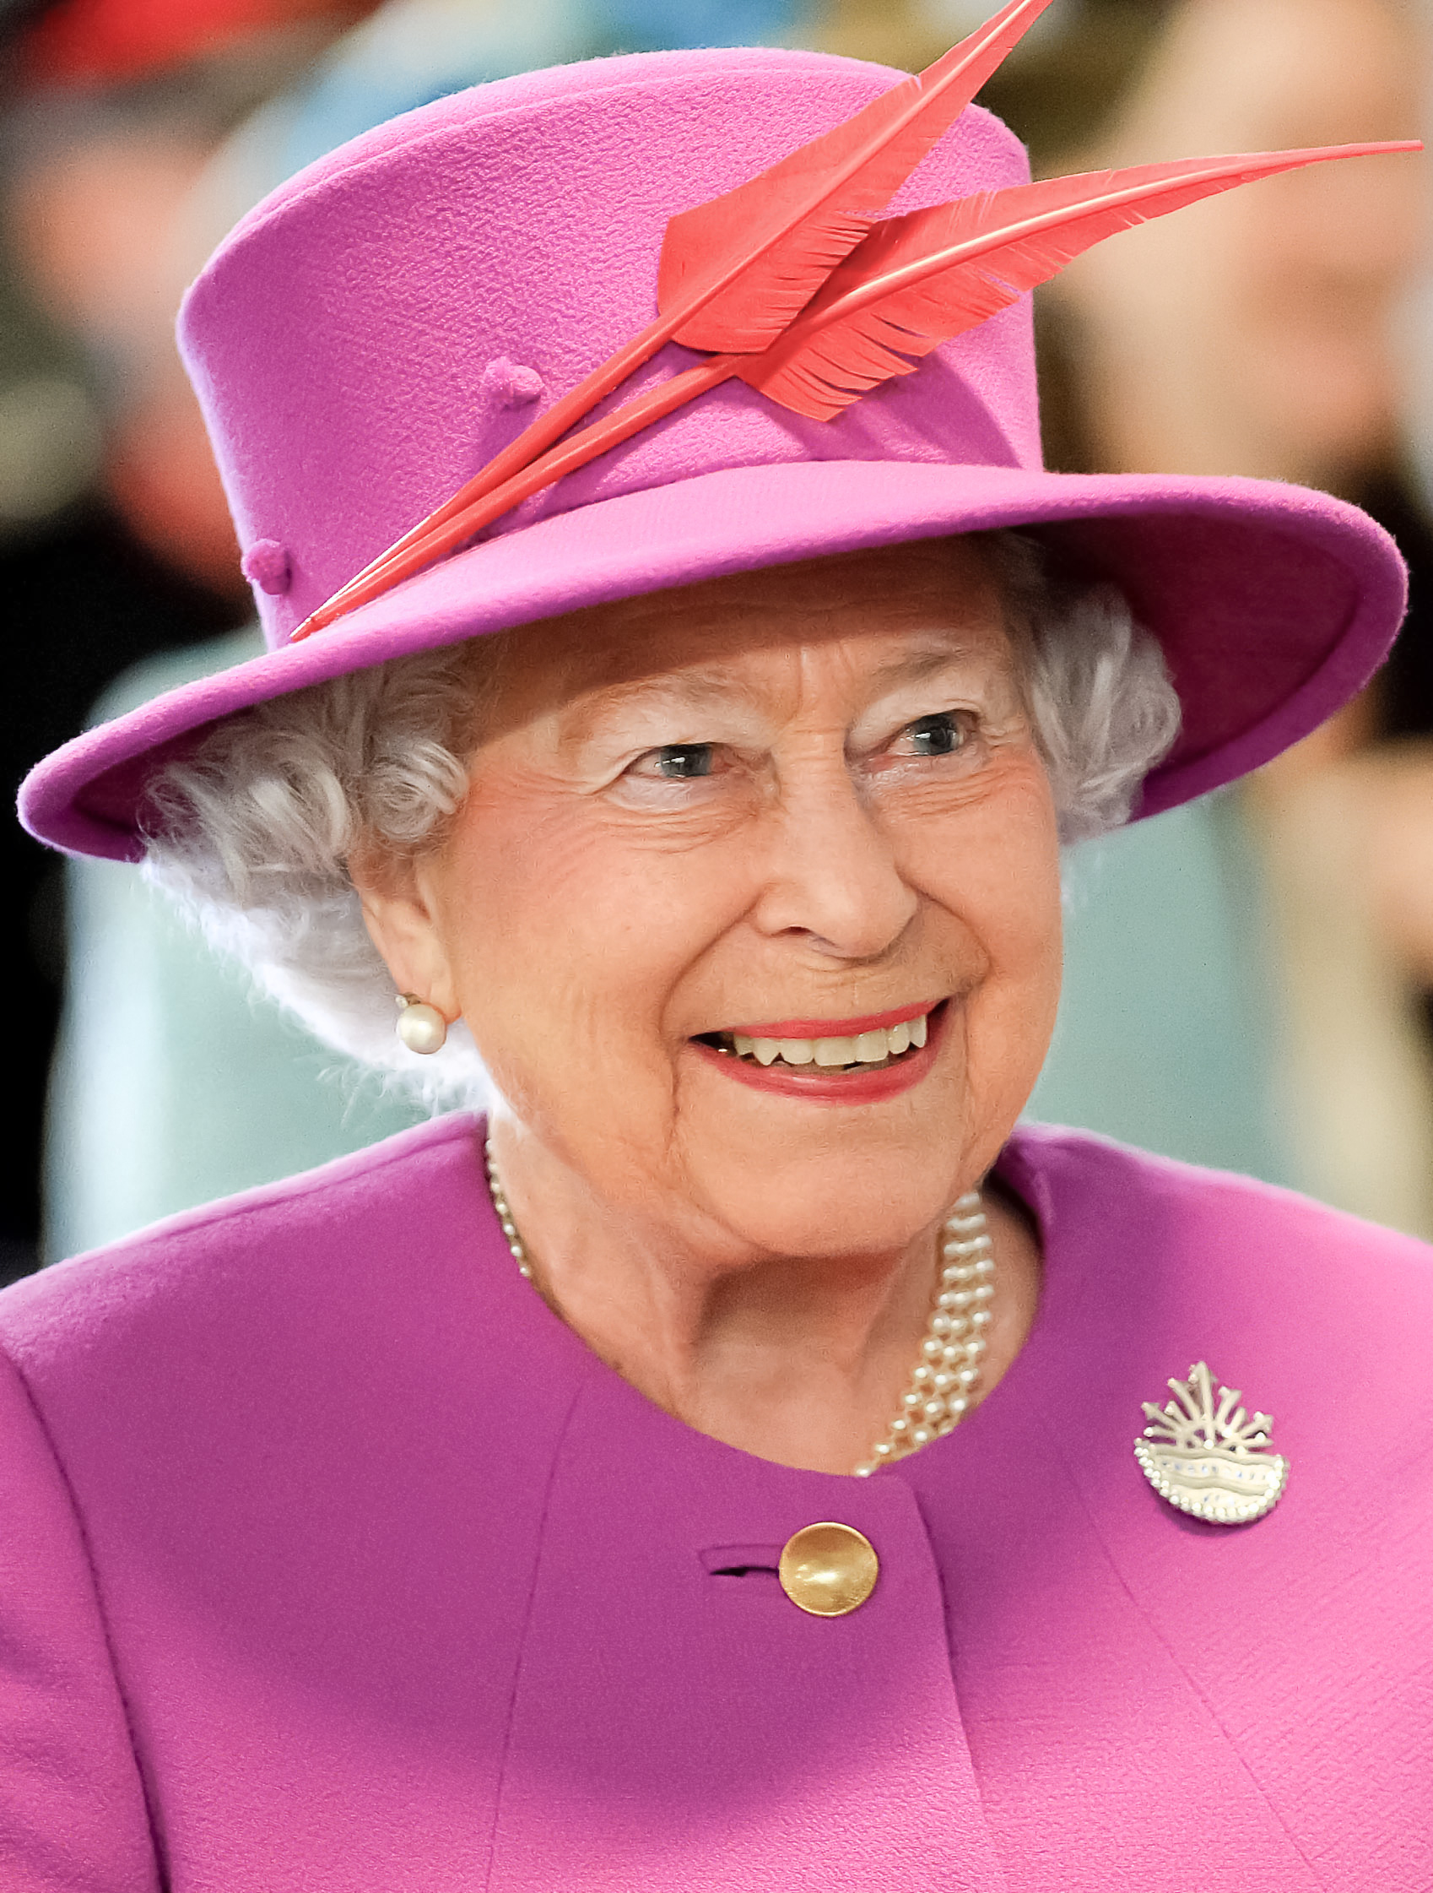

Children’s Activities

Make or draw symbols of the monarch, the items received at coronation, and learn their meaning:
- The sceptre with an orb and a cross on top – symbolises the rule of Jesus Christ over the earth. The monarch holding this sceptre, signifies that she is a servant of an even greater monarch, Christ.
- A Bible – symbolises wisdom. The monarch is guided by the Word of God.
- Sword of Mercy, Curtana – (with a broken tip) symbolises mercy. The broken tip reminds monarchs that they must practice mercy in their judgement. Micah: What does the Lord require of you? To act justly and to love mercy and to walk humbly with your God.’
- Rod of Equity and Mercy – symbolises mercy and equity. The sceptre is topped with a dove, a symbol of peace and the Holy Spirit.

More Music Possibilities

Alternative hymns by URC writers:

Hymn Option 1 – Refresh our lives — Sam Goodman (URC)
Tune: Was lebet was schwebet, O worship the Lord in the beauty of Holiness

Refresh our lives bring us back to this Holy place
Where we feel held in the love that you show
Let mercy flow, hold us tenderly in your grace
Build up your church let our love for you grow

Restore in our lives that great spark that you gave to us
Relight the fire that once burned in our hearts
Challenge us daily to trust you to strengthen us
Use us to serve, let your miracles start

Revive us with water that won’t make us thirst again
Deepen our longing to seek for the truth
Kindle our yearning to put your way first again
Give us the courage to stand up for you

Redeem your people and gather the wanderers
Comfort the mourners, replenish our love
Bring us your hope, only you can deliver us
Guide us with patience to wait on your call

Rejoice with the spirit, the sanctuary fills with praise
Come here with joy, let God’s name be proclaimed
Let love rebound from songs and psalms that we raise
Hold in our hearts the full awe of God’s name

Hymn Option 2 In tenderness enfold us by Sam Goodman, UK
Tune: Crüger, Hail to the Lord’s anointed

In tenderness enfold us, engage with us in prayer
And as you gently hold us, remind us that you’re there
Send light into our darkness
Breathe love into our lives
Send blessings down upon us
Let hope and mercy thrive

Be in the prayer we offer, shine in the love we share
Give comfort when we suffer, relationships repair
Guide us to where you need us
To where your word is heard
With bread that lasts, please feed us
So we in turn can serve

Give us the hearts that long to wrap those we meet in care
Fill us with courage, strong too, yet gentle in our prayer
May all we do be worthy
To be done in your name
May your desire burn in us
As we pass on your flame

Come fill us as you feed us to share you everywhere
A body of believers refreshed and moved by prayer
With hearts that show compassion
With hands that do you will
With trust and with your passion
Your calling to fulfil

Anthem options
Anthem Option 1: Choir anthem

Anthem Option 2: Anthem sung at Golden Jubilee in 2012. (5 minutes long)
Play from a recording or online. Follow link for recording and directions as to acquiring permission.
https://willtodd.co.uk/products-page-2/choir_and_keyboard/the_call_of_wisdom/
‘The Call of Wisdom’, by composer Will Todd; lyrics by Michael Hampel;
Commissioned by the Chapter of St Paul’s Cathedral for the Diamond Jubilee of HM The Queen, sponsored by The Worshipful Company of Horners.
Published by and available for purchase from Oxford Press.

Lyrics: (all information is available at link above)
Lord of wisdom, Lord of truth, Lord of justice, Lord of mercy;
Walk beside us down the years till we see you in your glory.
Striving to attain the heights, turning in a new direction,
Entering a lonely place, welcoming a friend or stranger.
I am here, I am with you. I have called: do you hear me?
Silver is of passing worth, gold is not of constant value,
Jewels sparkle for a while; what you long for is not lasting.
Rulers govern under me with my insight and my wisdom.
Those who know me know my love, those who seek me find their answer.
God the Father and the Son, Holy Spirit co-eternal.
Glory be ascribed to you, now and to the end of ages.

Anthem Option 3: O thou the central orb of righteous love
(sung at Jubilee service 2012) words: HR Bramley (1833-1917) ; music by Charles Wood (1866-1926) [note – uses all inclusive language!]
- O Thou the Central Orb - Wood - YouTube (music and lyrics accompanying singing
- (1) Charles Wood - O thou the central orb - YouTube recording from the National Service of Thanksgiving to Celebrate The Diamond Jubilee Of Her Majesty The Queen at St Paul's Cathedral, Tuesday 5th June 2012
- (1) Charles Wood Summer School - O Thou, The Central Orb - Wood - YouTube - sung and signed; The Charles Wood Summer School Singers conducted by Robert Blake

O Thou, the central orb of righteous love,
Pure beam of the most High, eternal Light
Of this our wintry world, Thy radiance bright
Awakes new joy in faith, hope soars above.

Come, quickly come, and let thy glory shine,
Gilding our darksome heaven with rays Divine.

Thy saints with holy lustre round Thee move,
As stars about thy throne, set in the height
Of God's ordaining counsel, as Thy sight
Gives measured grace to each, Thy power to prove.

Let Thy bright beams disperse the gloom of sin,
Our nature all shall feel eternal day
In fellowship with thee, transforming day
To souls erewhile unclean, now pure within. Amen.

Anthem option 4: The National Anthem
(This might be included after the last hymn. Second verse to be sung joyously)

God save our gracious Queen!
Long live our noble Queen!
God save the Queen!
Send her victorious,
Happy and glorious,
Long to reign over us,
God save the Queen.

Thy choicest gifts in store
On her be pleased to pour,
Long may she reign.
May she defend our laws,
And ever give us cause,
To sing with heart and voice,
God save the Queen.

This service was compiled by the Revd Dr Ana Gobledale with members of the United Reformed Church.

Revd Carla A. Grosch-Miller (URC ordained Minister), Psalms redux: Poems and prayers (Canterbury Press, 2014), used with permission
Revd Ana Gobledale (URC ordained Minister) serves Salisbury URC and edits the liturgical website, Worship Words. Used with permission.
The Inclusive Bible: The First Egalitarian Translation, Rowman & Littlefield Publishers, Plymouth UK, 2007; ‘God’ replaces ‘YHWH’.
Queen Elizabeth, Christmas 1984 (p 42-43 in The Servant Queen: and the King she serves, by Mark Greene & Catherine Butcher, published by Bible Society, HOPE, LICC, 2016)
Queen Elizabeth, 2011 (p.42 in in The Servant Queen: and the King she serves, by Mark Greene & Catherine Butcher, published by Bible Society, HOPE, LICC, 2016)
‘Help Us: Echoes of the Jesus Prayer’ written by Mary Carpenter while a member of St Andrew’s URC Brockley, London. Used with permission.
Revd Duncan Wilson (URC ordained Minister) writes contemporary versions of psalms for his project ‘Praise from the heart: The Psalms in liturgical order’. Used with permission.
Revd Ray Stanyon (URC ordained Minister) serves Wessex Synod; Words © RNC Stanyon 2019, used with permission.
Sam Goodman, URC ordained Elder serving Central URC in Derby. Used with permission.
Stephen Best (URC ordained Minister) serving the Cardiff and Penarth URC Pastorate, Wales. These lyrics were written originally for Stephen’s ordination service. Used with permission.
Karen Campbell (URC ordained Elder & Church Related Community Worker) serves as URC Secretary for Global & Intercultural Ministries.
Revd Stephen Best (URC ordained Minister) serving the Cardiff and Penarth URC Pastorate, Wales. Inspired by 1 Corinthians 13. Used with permission.
from pages 10-11 in ‘The Servant Queen,’ by Mark Greene & Catherine Butcher
Revd Cara Heafey (URC ordained Minister) serving at Summertown URC and Chaplain in the Oxford Hospitals.

