THE UNITED REFORMED CHURCH
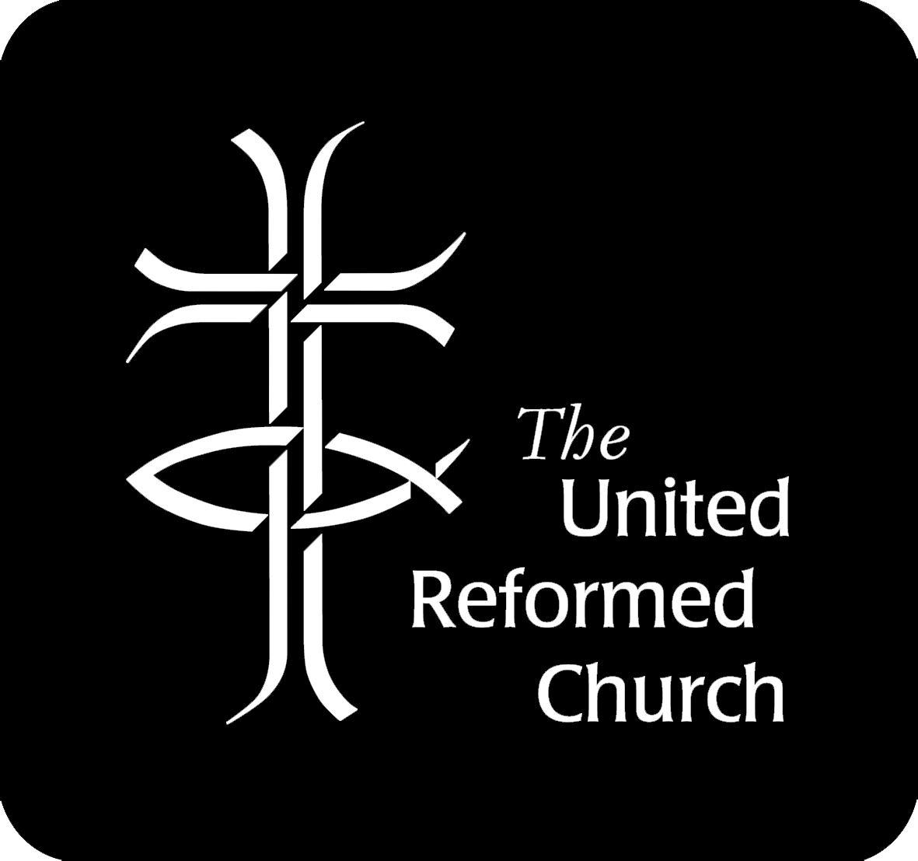
OPT OUT NOTICE
IF YOU WANT TO OPT OUT OF PENSION SAVINGS, FILL IN THIS FORM AND RETURN IT TO:
The Pension Fund Administrator, Church House, 86 Tavistock Place, London WC1H 9RT

Full Name (Jobholder)
Name of the Employer | The United Reformed Church
National Insurance No
Date of Birth
Date form completed

What you need to know
- The Church cannot ask you or force you to opt out of the Pension Fund.
- If you are asked or forced to opt out you can tell The Pensions Regulator – see www.tpr.gov.uk
- If you change your mind you may be able to opt in – write to the Fund Administrator if you wish to do so.
- If you stay opted out, the Church will normally put you back into pension saving in around 3 years.
- If you change your job, your new employer will normally put you back into pension saving straight away.
- If you have another job your other employer may also put you into pension saving, now or in the future. This notice only allows you to opt out of pension saving with the United Reformed Church. A separate notice must be filled out and given to any other employer you work for, if you wish to opt out of that employer’s pension saving as well.
Statements and warnings
By completing this form I am confirming that:
- I wish to opt out of pension saving
- I understand that if I opt out I will lose the right to pension contributions from the Church
- I understand that if I opt out I may have a lower income when I retire.

I confirm that I, the jobholder, personally completed and submitted this notice.

Signature

