To be printed on the Church’s letterhead
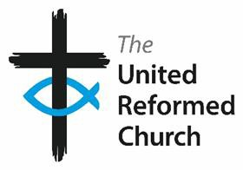
Addressee Name

Dear [name}

Consent Form
The elders of XYZ United Reformed Church collect and process data in accordance with our Data Privacy Statement which is displayed state where it is displayed.
However the elders now wish to collect and process data which goes beyond the scope of the Data Privacy Notice and we therefore seek your express permission to do so.

The data we will be collecting and processing
The reason we are collecting it
Where and how the data will be held
How long we will be holding the data
Please indicate your consent to XYZ United Reformed Church processing this data by signing and dating below.
We will retain this form as evidence of your agreement to the processing of the data until such time as the data is destroyed.
You may withdraw your consent at any time by writing to the Church Secretary.

Yours sincerely
………….
On behalf of the elders of XYZ United Reformed Church

I,………………………………….(full name) consent to the processing of my personal data in accordance with the details above.

Signature |  | Date

