WEATHER CHART FOR WEEK BEGINNING :
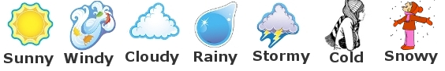
Use the chart below to record the weather for one week where you live and in a place in Nicaragua. https://www.worldweatheronline.com/granada-weather/granada/ni.aspx Draw in symbols for sun, rain, cloud, stormy, windy and record the temperature. Do this for a month, and then compare the weather between the two places. What do you notice?

Day/Date | My Home Town | Town in Nicaragua
Monday
Tuesday
Wednesday
Thursday
Friday
Saturday
Sunday

