Welcome to November’s newsletter.

As autumn gives way to winter, the changing season reminds us that God is at work in ways we cannot always see. In children's and youth ministry, we often have the privilege of witnessing moments when faith is expressed openly, however, much of our work happens in quieter ways. Through conversations, prayers, acts of welcome, and faithful presence, we accompany children and young people on their journey of faith. While the significance of these moments is not always immediately visible, we trust that God is at work through them. As Advent draws near, we remember that God's kingdom is revealed in a similar way, not through power and spectacle, but in the unexpected coming of a child, bringing hope into the ordinary realities of everyday life.

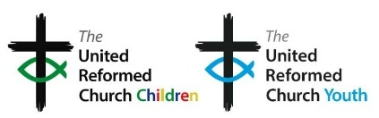
Advent reminds us that incarnational ministry begins with God's own action: God did not remain distant but came to live among us in Jesus Christ. In the same way, much of our ministry with children and young people happens through presence, relationship, listening and walking alongside them in everyday life. When we do this, we embody Christ's love in our churches, communities, schools and organisations. We at the Offices of General Assembly are deeply grateful for your faithfulness, creativity and care. As Christmas approaches, we pray that you will find time to pause and wonder again at the gift of God-with-us, and be renewed by the hope, peace, joy and love that the Incarnation brings.

Jo


Advent is such a special time, one in which we often see more families walk through our doors. We understand that it can sometimes be difficult to think of new ways to explore Advent which is why we have created a section on the website dedicated to all things advent! https://bit.ly/AdventResourcesURC

There you will find frameworks for services for under 5s, youth and outdoor worship aswell as ideas for advent in the style of: brick church/ reflective story telling/ creative prayer and forest church. There are nativity suggestions, activity sheets and more. Take a look here: https://bit.ly/AdvenTResourceS



Exciting news – the Youth Mod blog has gone live!
Keep up to date on all goings on youth related around the URC. Save this link to ensure you don’t miss any monthly updates.
bit.ly/ModBlogURC
And here is a direct link to Kacie and Alex’s latest post: https://urc.org.uk/welcoming-and-inclusive-an-open-invitation-to-youth-assembly/

LUNDIE MEMORIAL AWARD CELEBRATING CHILDREN AND YOUNG PEOPLE

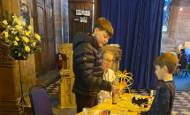
The Lundie Memorial Award celebrates the good work an individual child or young person is doing for their church and community.
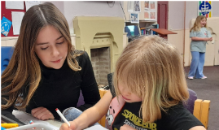
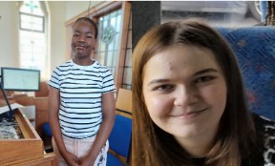
If you know a child or young person who is playing their part in the mission of God in their church or Synod, their local community or the wider world, please nominate them for a Lundie Memorial Award and help shine a light on their achievements.
Each month, a medal and certificate will be awarded to one of the nominated children and young people, along with a financial gift of £100 to be spent to benefit children and/or young people in the church, synod or local community, however the award winner chooses.
Perhaps there is someone in your church who is 25 years or younger who you would like to nominate for this award? Only 30 awards remain so be quick! Details can be found here: bit.ly\URCLundie

********Children and Youth workers conference********

We're planning a national weekend for children, youth and intergenerational workers in the United Reformed Church on 1–3 October 2027.
We want it to be a weekend that equips, encourages and inspires those involved in ministry with children, young people and families.
Your feedback will help shape the location, programme and priorities for the weekend. Thank you for helping us make it the best it can be.
https://docs.google.com/forms/d/e/1FAIpQLSdL_oPRj20Ob249aKiKAJ9r1d4QtV8Ai81UNNc9dGNWtmrQDA/viewform

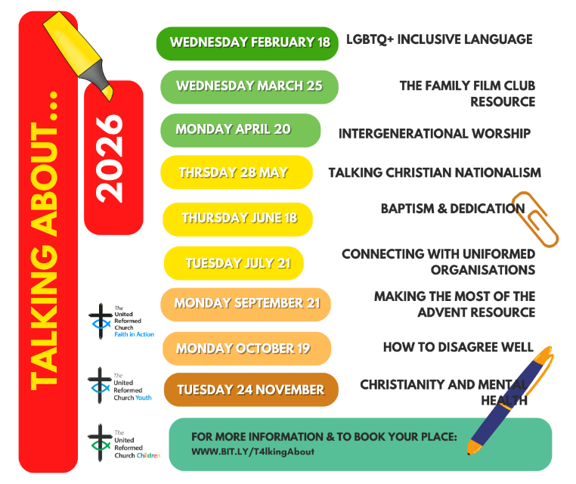

Did you know that most of the talking about sessions can be found on our YouTube channel: https://bit.ly/YTplaylistURC






………………..would like to introduce you to the new Parenting for Faith Five Key Tools Course.
'The Five Key Tools Journey is a six-session course for parents and carers, introducing five key tools for helping children and teenagers grow in faith.
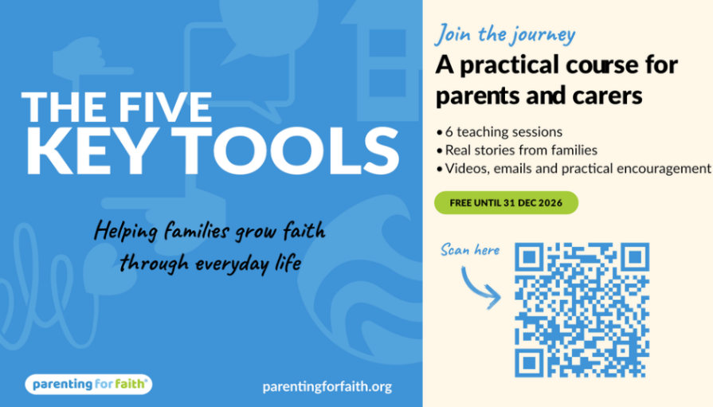
Every fortnight from 15 September, you’ll receive a new 20-minute video teaching session, plus a 20-minute bonus episode featuring real families trying the tool out. You can watch or listen whenever it suits you — on BRF Online, in your podcast app, or with others as part of a group.
Parenting for Faith | The Five Key Tools Journey: FAQs

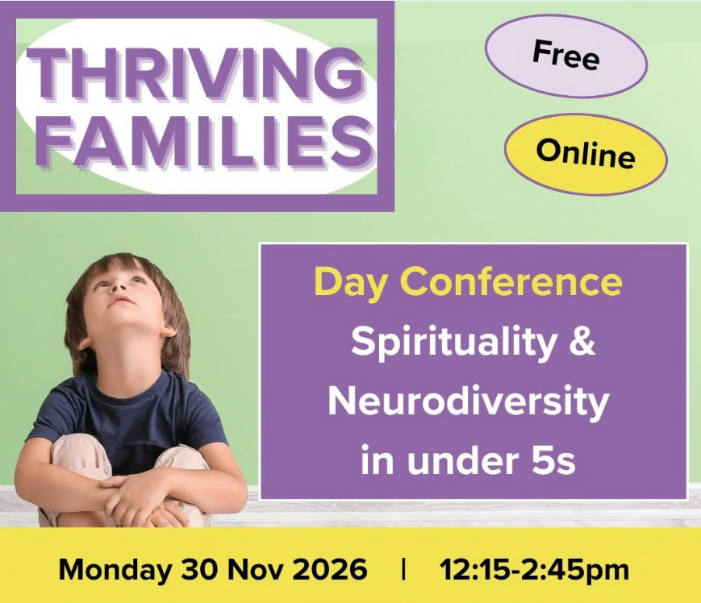
Grounded in the belief that all young children, including those who are neurodiverse, are naturally open to spiritual experience, this event explores how environment, routine, and simple practices can nurture welcome, inclusion and faith from the very beginning. Led by Bekki Bibko from charity Growing Hope


LOOKING AHEAD - for your diaries or your prayers
24 November Talking About…Christianity and mental health
30 November Thriving families
30 November Complete survey
26-28 February 2027 Youth Assembly
1–3 October 2027 Children and youth conference

Next Bi-Monthly Update: January 2027
Help Shape Future Resources
What's working well? What's missing? Your experience can help shape resources for children, youth and intergenerational ministry across the URC.
Scan the QR code and complete the survey by 30 November 2026 and help us create resources that truly meet the needs of our churches: URC Children's, Youth and Intergenerational Resources Survey – Fill in form

