REGISTRATION AND CONSENT FORM For Supersleuths Holiday Club at _____________________ Church

Details of young person

Full name: ____________________________________________________________________________________

Address: _____________________________________________________________________________________

________________________________________________ Postcode: _____________________________

Date of birth: __________________________________

Doctor's name, address & telephone number: ______________________________________________________

____________________________________________________________________________________________

Current medical conditions/illnesses (including asthma, allergies, migraine, diabetes, epilepsy, etc):
___________________________________________________________________________________________

___________________________________________________________________________________________

Any medication currently being taken: ___________________________________________________________

___________________________________________________________________________________________

Any additional needs (e.g. special dietary requirements, disability, etc):
___________________________________________________________________________________________

___________________________________________________________________________________________

Please fill in this information, if you know it: Blood Group: ____ Date of last anti-tetanus injection: _________

Contact Details of parent/carer/person legally responsible for young person

Name: ___________________________________________ Relationship: ________________________

Address: __________________________________________________________________________________

Home phone: __________________________________ Other phone: ______________________________

Email address: _____________________________________________________________________________

Details of alternative emergency contact

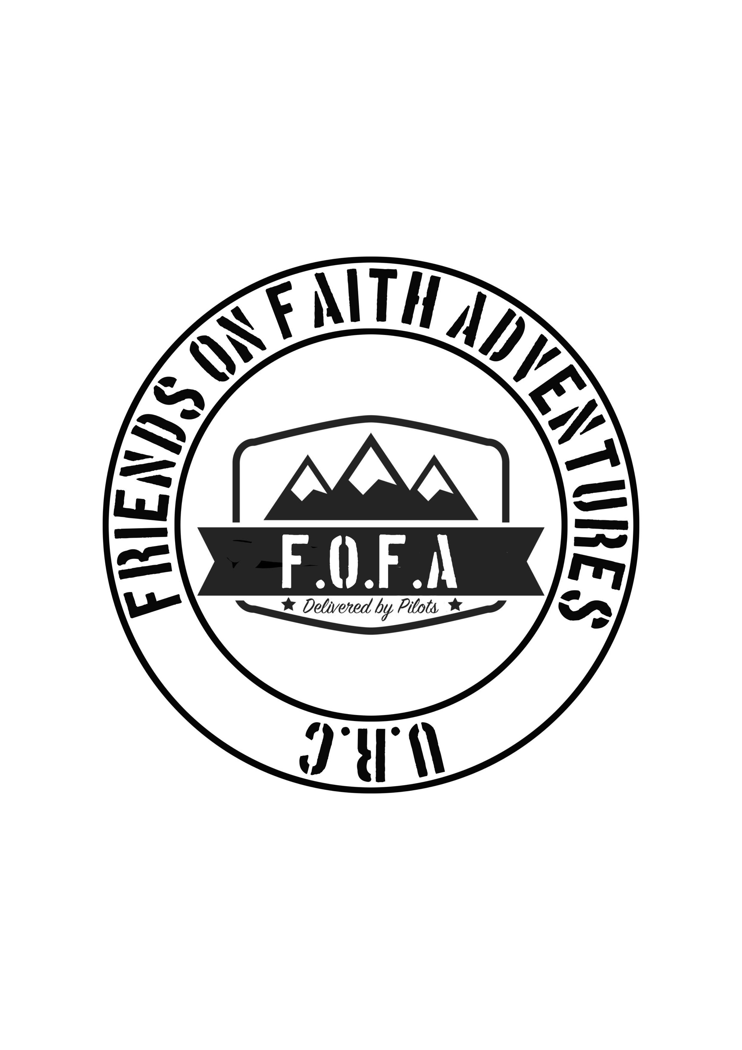
Name: __________________________________________ Relationship: _______________________

Home phone: __________________________________ Other phone: _____________________________

Give details of the adult who will be collecting your child at the end of each session

Name: _____________________________________ Contact Phone number: _____________________
General consent
Please read these statements and make sure you understand them. It is important that a parent, guardian or someone with legal responsibility for the young person sign these statements.

I give consent for ________________________ to attend and take part in Supersleuths Holiday Club. I acknowledge t the need for them to behave responsibly and to take note of any safety instructions.

I understand that while involved they will be under the care and supervision of the approved adult workers appointed by the church. While these workers will take all reasonable care of the participants, they cannot necessarily be held responsible for any loss, damage or injury suffered during, or as a result of, the activity.

In the event of illness or accident requiring emergency treatment, I give my consent for my child to receive emergency dental, medical or surgical treatment as considered necessary by medical professionals. I understand that every effort will be made to contact me before any action is taken. In the event of minor injury, I give my consent for my child to receive first aid and understand that I will be informed after the event.

Signed: _____________________________________ Date: ___________________________

Photography and video:
time to time, designated adults at the session may take photographs or videos of the participants to provide a reminder of the event for those involved and to use on church displays, posters and flyers, church website, and occasionally in the local press. Photos or videos used publicly will focus on activities and groups rather than individuals; they will not show the outside of an identifiable building and participants will not be named or linked with any personal details. Photos or videos will not be taken if the participant is themselves unwilling. Photographs and video material may be used by the church and by the URC Children’s and Youth Work team at Church House.

No photographs will be taken by participants in the holiday club other than those leaders designated as official photographers for the event.

Are you happy for photos / videos to be taken of the participant named on this form? Yes / No

Please circle Yes or No to make clear in which ways you are willing for them to be used:
Displays within the church Yes No
Publicity (e.g. posters/flyers) for future holiday clubs Yes No
Church or URC official Website Yes No
Church or URC official social media Yes No
Press Yes No
I give consent for photos/videos of the participant named on this form to be used, as above.

Signed: _____________________________________ Date: ___________________________

GDPR
For further information on how your personal information is processed, please see our Data Privacy Notice which is available __________________________________________.

Holiday Club General Information and Consent form

