Easing out of Lockdown – what next?

At the beginning of lockdown in this coronavirus pandemic, the Tragedy and Congregations team offered a short document on ‘Thoughts for Ministers in the first phase of the coronavirus crisis’ https://tragedyandcongregations.org.uk/category/blog which is still worth revisiting for the information on trauma reactions.

Stress is exhausting
15 weeks on, as we begin to ease out of lockdown, I wonder what your reaction was to the news that churches could open again for private prayer and then for public worship at the beginning of July? If the Twitter-sphere is anything to go by then it is, as would be expected, a very mixed experience, with some really glad and able to be back in church again, and others more cautious or unable to open up for various reasons. But whatever your situation, just coping with the experience of the past 15 weeks will have been exhausting on a personal and professional level, as well as psychological and emotional. The stress reaction to a crisis is fuelled by the release of adrenalin to help us respond as best we can. But that stress response is only meant to last for a short time to deal with an immediate event - not 3 months and counting! It will be in our bodies as well as our minds that we will be registering the effects of this.

Take time out
In a recent poll of clergy in the Diocese of London, it emerged that 72% had not had any time off since lockdown began. It’s understandably been really difficult to take time out during lockdown but it is vital for ministers and church members to take time out over the summer, whatever that will look like. Your whole brain-body needs to rest and allow the nervous system to reset before ploughing on to the next phase of this crisis. Self care is vital if we are in this for the long-haul.

Take time to reflect
You may have come across the saying, “we have travelled so far, so fast, that now it is time to sit and let our souls catch up with us”. I’ve seen it in various forms, but the truth of it is important for this in-between time from one stage of the pandemic to the next. It’s important for us on a personal level, but also for ministers to be able to encourage church members and church leaders to reflect on their experience and where we are now. There is no ‘going back to normal’ as many of us wish for, and there will be many losses to acknowledge and grieve, as well as new insights, initiatives and opportunities that have emerged. But most importantly, what has shifted within ourselves as people and congregations? What have our experiences been and what have we learnt? When we travel this road of reflection, we are better able to make life-giving choices about how to move forwards as God’s people on the Way.

Living with the unknown
One of the hardest things of living through this pandemic crisis is living with uncertainty, with the anxiety of simply not knowing. Nobody knows how this will all turn out, and what ups and downs there will be on the way. It makes us feel insecure and vulnerable. How can we resource ourselves to live with such vulnerability – both our own and as leaders, trying to hold it for others? For leaders in these times, it means holding your nerve and being prepared to live with the vulnerability of ‘not knowing’ the answers, but being prepared to work them out together.

The poet – Maria Rainer Rilke counselled his ‘young poet’ to be patient with the uncertainties in his heart, to ‘love the questions themselves’ and to live them, without seeking answers. He would not be given the answers, wrote Rilke, because he could not live with them. Instead he should ‘Live the questions now.’ ‘Perhaps [we] will then gradually,’ suggests Rilke, ‘without noticing it, live along some distant day into the answer.’

We are travelling this journey as the disciples did in the experience of Holy Saturday – of the extreme vulnerability of not knowing the outcome, nor of what lies ahead. What holds us is that we are accompanied; Jesus has travelled this road. We can only be present to the experience and live into it in the company of the one who is faithful and who holds our souls in being.

Hilary Ison with Christopher Southgate, Carla Grosch Miller July 2020
tragediesandcongregations.org.uk

A visual aid to help us reflect on our experience in the storm….

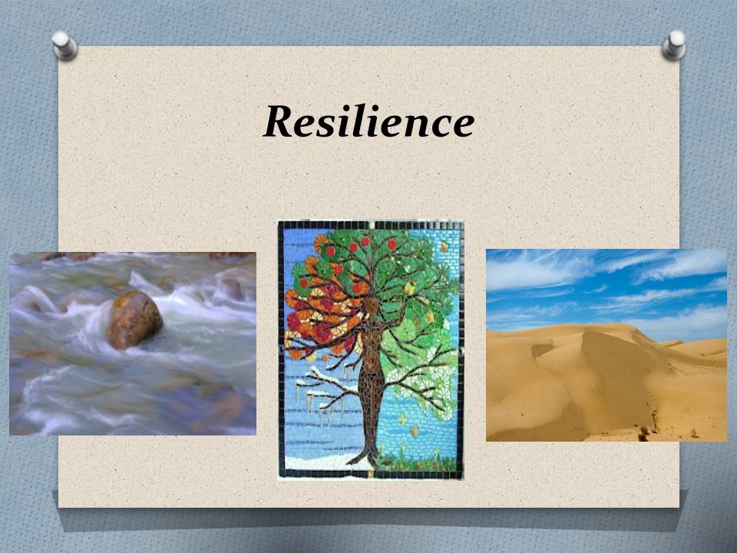
3 Representations of resilience:

- the rock – solid, unmoved as the waters swirl around it in the raging river

- the tree – well rooted in the ground, able to bend and flex with the wind and all that
buffets it

- the sand dune – the storm lifts up the sand and swirls it around so when it lands again after the storm, it is still sand but completely refigured in shape and form

In what ways do any of these representations speak to my experience or that of the church?

Rainer Maria Rilke, Letters to a Young Poet, (Tr. M.D. Herter Norton; New York/London: Norton, 1993), 35 (italics in the original).

