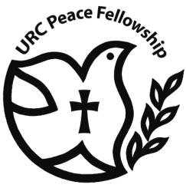**United Reformed Church**

**Peace Fellowship**

***ANNUAL CONFERENCE 2016***

***a joint event with the Baptist Peace Fellowship***

***Saturday 29 October***

***11.00 am – 3.30 pm***

***at Bloomsbury Baptist Church,***

***235 Shaftesbury Avenue, London WC2H 8EP***

***Speaker:* Revd Stephen Keyworth**

**Faith and Society Team Leader**

**for the Baptist Union of Great Britain**

***“Exploring the peace legacy of Martin Luther King and its global message for today”***

Sandwich lunch and tea/coffee will be provided.

Please return the booking slip to:

Church and Society, United Reformed Church, 86 Tavistock Place, London WC1H 9RT

(020 7916 8632; e-mail: church.society@urc.org.uk)

………………………………………………………………………………………………………………………………………………………………………

**URC Peace Fellowship Conference, 29 October 2016**

I/We hope to attend.

*Name(s) ……………………………………………………………………………………………………………………………………………..*

*Address …………………………………………..………………………………………………………………………………………………..*

*…………………………………………………………………………………………………………………………………………….*

*Email ...................................................................................................................................................*