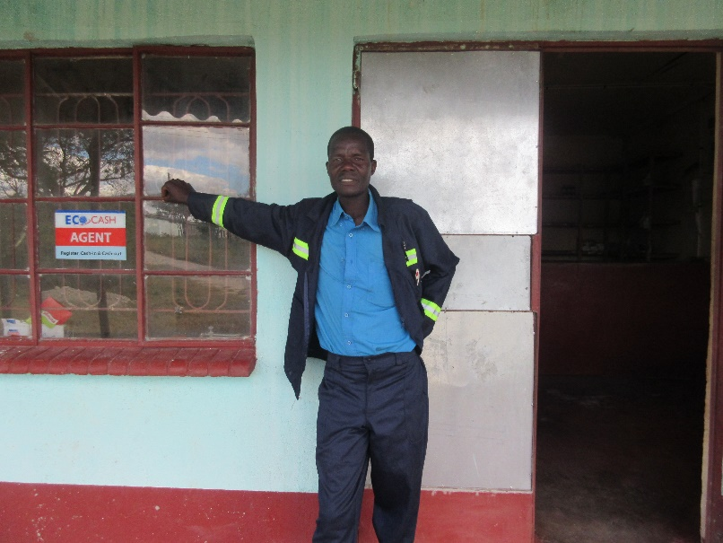
No time to rest

Precious Moyo, the oldest of five children, is particularly proud and happy that he was chosen by his village to receive building training from Silveira House, supported by Christian Aid. He says,
“I would like to thank you for your support. I can be someone and help my family.”
Precious found the training extremely useful and at the end was qualified enough to be asked to build a shop for a local businessman.
He is part of the Sonke Sakhile Builders cooperative. In the last few years, Silveira House has trained around forty-seven builders and carpenters, five of which were women. Most are between 18 and 35 years old. The group operates out of a new building, which was given to them as part of the government workspace scheme lobbied for by Silveira House.
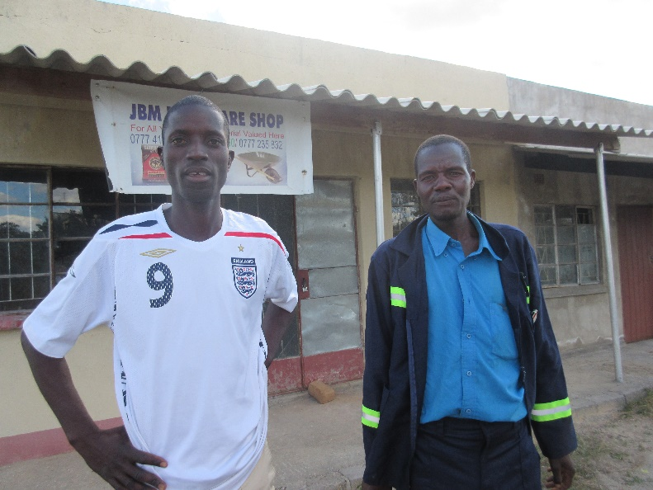
Precious is now working with his brother, Sibongumuzi Nyathi, fitting out another shop in the same area. He especially likes the fact that he can employ others to take on such tasks as mixing the concrete or unloading.
He explains,
“It is good to be at work as it means I am not hanging around home. I like it so much as there is no time to rest.”
Working has meant that he can support his mother and father as well as buying himself some cows.
Silveira House are particularly keen that those they train go on to get recognised qualifications. Precious understands this,
“Upgrade yourself so you can train others. Do the formal training and then you can train others in your community.”
Christian Aid partners see this form of multiplying as the key to helping a whole community develop and prosper. Helping others gives confidence and self-esteem. Precious Moyo, builder, knows that.

Image 1: Precious Moyo outside the first shop he helped fit out
Image 2: Precious and his brother, Sibongumuzi Nyathi, outside the shop they are working on together
LMM June 2017

