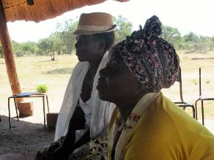
A family business – Tendani Masendu
A loan of just US$200 dollars from her village bank gave Tendani Masendu the chance of security and confidence for her family’s future. Like many in Masendu ward, Tendani is the head of the household, as her husband lives and works permanently in South Africa. With many children to look after, the irregular monies from her husband mean she needs extra income.
Through Christian Aid partner, Institute of Rural Technologies (IRT), Tendani trained in retailing and was given a loan to start a shop, selling clothes and other goods she bought in Botswana. She was determined to make this work, so was delighted to expand into the shop next door and increase her stock. At one point, she even sold car tyres.
“I used the loan to start selling second hand clothes. With 6 children, 1 orphan and 12 grandchildren, I needed the money. I bought small things at first and resold. My brother gave me a small space where I could sell children’s books, salt and other things. I make enough money to pay for school fees and food.”
Tendani is part of a village bank. Village banks started helping small businesses in 2008 with contributions from women. At that time, there was no money. The village bank started as a means of pooling money together for people to go to workshops. This changed when IRT, with funding from CA, started lending to the women’s groups. The system is credit union style money lending with the village group having responsibility for the fund. They were taught how to identify good projects and monitor progress, so when people come to the committee with a proposal, they can decide if this is a worthwhile project. If approved by the group, then IRT will match fund the local offer and give appropriate training.
If someone defaults on a loan, they are taken to the traditional court. If they have not paid because their circumstances have changed and they are vulnerable, then the debt will be cancelled. If they have not paid because of lack of effort or they have used the money for other purposes, then they are asked to work off the amount owed in community service
Today, Tendani employs two people and her standard of living has increased. Her daughter has received training in marketing and booking, so it can now be called a family business.
“I feel I am free in life because I can feed myself. I am self-sufficient. I am not going to lose sleep thinking.” What a wonderful testament to the work of IRT.

Image: Tendani (with hat) and another member of the village bank
LMM 2017

