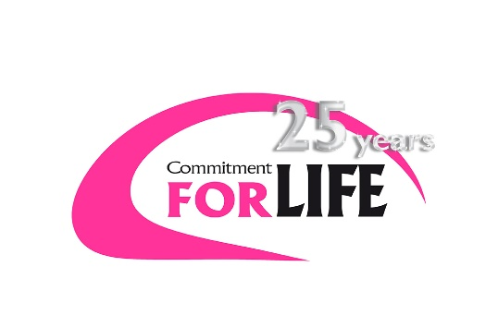**BANGLADESH**

**Feroza Begum**

At 1,800 miles long, the Brahmaputra River flows through Tibet, India and Bangladesh. Every year, when the snow at its source melts, it can cause catastrophic flooding.

For people living in the Char islands in northern Bangladesh, their lives and livelihoods can be precarious. Isolated from the mainland, these poor communities are at the whim of the river and an ever changing climate.

Our partner GUK’s staff make a daily four hour round trip to the Chars six days a week to deliver a project that is transforming the lives of people there. This work has made locals more resilient, self-sufficient and knowledgeable about how to live in this tough environment.

Feroza Begum and her family, who you may have heard about during Christian Aid Week 2016, arrived in Bazetilcupi Char four years ago after being flooded from their home. GUK identified Feroza and her family as ‘ ultra poor’

At that time, Feroza’s husband Joynal was having to work far away in Dhaka as a day labourer. Their income was on average 66p per day. ‘I feel like crying when I think of those times,’ Feroza told us.

Feroza was supported with cattle, poultry, the raising of her homestead (to protect it from flooding), training in agricultural techniques, and workshops in rights awareness. Now her assets are worth more than £3,500. Feroza has status in her community, owns land and is ambitious in her hopes for the future

Four years ago, Feroza and her family’s life looked very different. Such was their poverty that she described wanting to ‘break off her hands and legs’ because she felt so useless. But with the support of GUK, she turned things around and is now able to make choices to improve her family’s lives.

Each year, with increasing unpredictability, flooding and river erosion affect the lives, livelihoods and homes of Char dwellers like Feroza.

In the Chars, there are few opportunities for economic development beyond agriculture. A widespread lack of employment means male family members are often forced to migrate seasonally for work.

These factors are contributing to a worsening social and economic situation for communities already on the margins of society.

As well as helping people earn a secure living, GUK is supporting them to improve their disaster preparedness, through early warning systems, emergency contingency planning and the provision of emergency shelters. A crucial aspect of the project has been the raising of people’s homesteads, to protect their homes, animals and crops from flood waters.

While Chars communities will always be vulnerable to disasters such as flooding, this project enables people to build their assets and financial security, so they can make choices and think to the future.

As Feroza told us: ‘Now I have more confidence. I enjoy more freedom and I have decision-making power. Even my value in my community has increased. What I have received from GUK has changed my life.’