Guidance for Scotland only (November 2012)
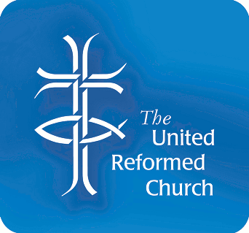

On 28 February 2011, the Scottish Government introduced a new
membership scheme to replace and improve upon the disclosure
arrangements for people who work with vulnerable groups –
The Protection of Vulnerable Groups (PVG) scheme.

Scheme membership was only open to new workers, but now will be rolled out over the next four years for people who have already had a criminal record check for working with children and young people using the old system. The new PVG scheme also includes people who provide specific, targeted services for vulnerable adults.
New volunteers should continue to join the scheme immediately.

Please do not submit any applications for people who have already been disclosed until you are told to.

Please note that some people in your congregations may already have joined the PVG scheme through their job and there is a different application form for people who are already in the scheme.

Safeguarding – everyone’s responsibility
Who should join the scheme?
Please visit the web site as there are two helpful documents http://www.urc.org.uk/ministry/children/safeguarding-children.html

The United Reformed Church uses the Churches Agency for Safeguarding to process our criminal record checks and they will continue to operate our applications to the PVG scheme.

Application Forms
- Application forms are available for Vulnerable Groups workers, paid or voluntary from the CAS (Churches Agency for Safeguarding): 020 7467 5216.
Application and verifier guidance notes can be found on their Website: www.churchsafe.org.uk
- Application forms are available for ministers from the Ministries office of the United Reformed Church: 020 7916 8634

Registered Verifiers
Church Secretaries by being appointed by their church to this role are automatically verifiers of identity however it is possible to nominate additional people but they need to be registered with the United Reformed Church. Please notify the United Reformed Church of any verifier nominations that have been agreed by your church meeting via email safeguarding@urc.org.uk or 020 7916 8683 prior to individuals verifying application forms.
Ministers, Local Church Leader or CRCW are no longer accepted as verifiers due to their work load.

If you have any queries please do not hesitate to contact safeguarding@urc.org.uk (Nov 2012)

